Polytan LigaTurf Cross GT zero on the training grounds of Bayer 04 Leverkusen

An impressive sustainability concept

Leverkusen is known for the Bayer Group and the closely associated Bundesliga football club Bayer 04, which represents attractive top-level football in Germany. The club remains a full subsidiary of the Bayer Group, for which, as in Wolfsburg, an exception to the 50+1 rule applies. Owing to its continued close association with Bayer AG, the team also refers to itself as the “Werkself” (the “Company Eleven”).

In addition to the men’s and women’s Bundesliga football teams, the club has various youth teams and a veterans’ team. The men’s team has played in the top division continuously since 1979. Its biggest successes so far include its victory in the UEFA Cup 1988, winning the DFB-Pokal in 1993, and reaching the Champions League final in 2002 – and not least, being five-time runners-up in the Bundesliga under coaches Christoph Daum and Klaus Toppmöller. The Bayer 04 women’s team has played in the first Bundesliga non-stop since 2018. Its biggest success so far is its victory in the DFB-Hallenpokal in 2015.

The men play out their matches in the renovated and extended BayArena, which not only has capacity for 30,210 spectators, but guarantees more proximity to the action on the field than almost any other Bundesliga stadium. Also part of the club is the Barmenia performance centre – the first of its kind in Germany. The facility now includes five natural turf pitches and one synthetic turf pitch. It is used for training and matches by the Bundesliga women’s team, as well as the age groups U8 to U15.

Bayer Leverkusen has chosen Polytan for the renovation of the synthetic turf areas at its training grounds. Over 10,000 square metres were fitted with the climate-neutral LigaTurf Cross GT zero. This is the world’s first 100% CO₂-neutral football turf, which meets the highest stands, even when subjected to heavy use. Its ecological benefits are based on sustainable, organic PE raw materials, sourced from sugar cane. The turf system, which is filled purely with environmentally friendly cork, is completely free from rubber granules. As well as being made of biobased raw materials, LigaTurf Cross GT zero is produced in Grefrath, North-Rhine Westphalia, using 100% green electricity.

In awarding the contract, Bayer 04 Leverkusen was swayed by more than just the surface, which combines environmental friendliness with sustainability, without compromising on durability and functional properties. The club was also impressed by the overall sustainability concept that Polytan had to offer in Leverkusen. This also included the professional removal of the old LigaTurf RS+ synthetic turf. After over 12 years and eight successful FIFA recertifications, it will now be replaced by its successor and recycled in an environmentally friendly manner in nearby Essen by FormaTurf, another subsidiary of the Sport Group Holding. The state-of-the-art facility is able to recycle up to 100% of a worn-out synthetic turf. During the recycling process, both the turf backing and filaments, as well as the infill, are fed back into the closed-loop material cycle. Lastly, FormaTurf processes the turf carpet and rubber granules into new plastic products.

The new Polytan LigaTurf Cross GT zero will in particular offer young talent at Bayer 04 Leverkusen optimal training opportunities on their path to becoming professional footballers. At the same time, it is a flagship project for Leverkusen and the entire region, as it shows that ecology and sustainability can be achieved using synthetic turf, without the need for rubber granules, which have been the subject of recent criticism. In addition, the surface aligns perfectly with the corporate club’s goals to make football sustainable and thus fit for the future.

Images:

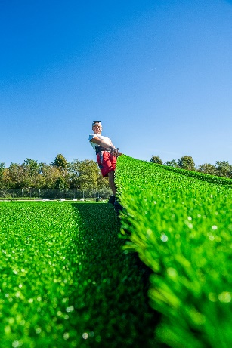

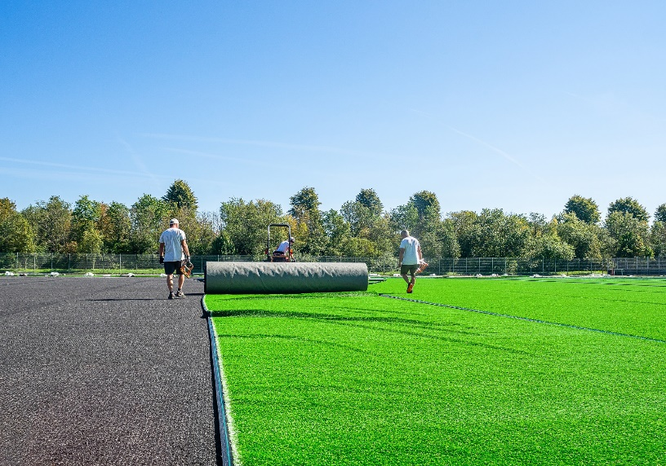

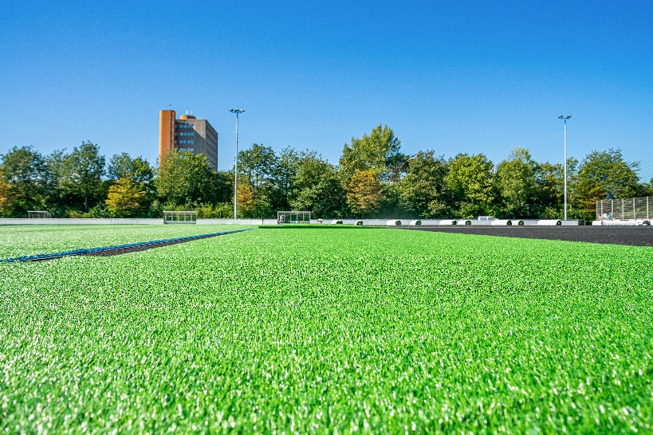

About Polytan:

Providing the optimal surface for athletic success – Polytan has pursued this aim with its sports flooring and artificial turf systems since 1969. And the bonus is that sustainability and environmental compatibility have always been a priority for us here at Polytan. The spectrum ranges from environmentally friendly raw materials and energy conservation during the manufacturing processes to the recycling of the surfaces. In line with its motto of “We make sport. Greener.”, Polytan is continuously and effectively improving the future of sports flooring. Polytan’s Green Technology line (GT) is the result of years of research and signals a new generation of state-of-the-art products and processes that combines specialised expertise with the functional and ecological benefits of renewable raw materials and resource-saving technologies.

Polytan’s portfolio is built for disciplines such as football, hockey, rugby, American football, athletics, tennis and multisport, and even offers fall protection. As well as developing, manufacturing and installing sports surfaces, Polytan also offers line painting, repair, cleaning and maintenance as part of its range of services. Polytan provides the largest sports surface installation network in Europe, the Middle East, Asia and the Pacific. All products comply with the current national and international standards, and have all the relevant certifications of international sporting associations, such as FIFA, FIH, World Rugby and World Athletics.

Further information is available online: https://www.polytan.com/ and https://wemakesport.polytan.com/.

Agency contact: | Company contact:
Seifert PR GmbH | Polytan GmbH
Clemens Ottmers | Tobias Müller
Zettachring 2a | Gewerbering 3
70567 Stuttgart, Germany | 86666 Burgheim, Germany
+49 (0) 711 / 77918-17 | +49 (0) 8432 / 87-71
clemens.ottmers@seifert-pr.de | tobias.mueller@polytan.com

