Polytan and MakinH announce strategic partnership

Dry hockey as the goal

German sports flooring manufacturer Polytan and Belgian sporting goods manufacturer MakinH are entering into a strategic partnership with one goal, which is to develop solutions for the current issue facing the hockey industry: dry hockey. Both companies are represented at this year’s FSB and will present their partnership for the first time at the Polytan exhibition stand (Hall 10.2, Stand E011) at 2 pm on Thursday 26th October. At the stand, there will also be a live demonstration of MakinH’s Rewetta® hockey ball on Polytan’s Olympic turf, Poligras Paris GT zero.

Advancing climate change forces us to rethink, and sport is no exception. In doing so, one of the key issues is reducing the consumption of water in hockey, which thus far has typically been used in unlimited amounts. A professional hockey game requires the field to be fully wetted. A single spraying procedure easily consumes 10,000–15,000 litres of water, meaning that each watered hockey field consumes millions of litres of water every year. In collaboration with the FIH, Polytan and its partner MakinH want to do their bit for sustainability by finding new solutions and placing hockey at the forefront of sustainable innovation. For example, the International Hockey Federation (FIH) has announced that the 2024 Olympic Games in Paris will be the last official hockey tournament at which full watering of the pitch is allowed.

The goal of the collaboration is to realise and further develop innovative and sustainable products for use in hockey. Polytan has developed Poligras Paris GT zero, the world’s first carbon-neutral synthetic turf for field hockey, specially for the Olympic Games in Paris. The GUcert-certified surface is produced up to 100% climate-neutrally, without compromising on playing characteristics, not least thanks to a fundamentally improved product design that leads to reduced water consumption. Thanks to TurfGlide technology, an innovative and proprietary technology, it reduces surface friction so that even less water is needed to reduce the friction resistance, and minimises the risk of injury. Poligras Paris GT zero is currently the only turf that is approved for the category of water-based hockey turf and the new FIH innovation category “Non-Irrigated”.

The Belgian sporting goods manufacturer MakinH has also developed a recyclable, self-wetting Rewetta® ball, which reduces the water consumption needed for a fast, professional game by eliminating the need to spray the field with water. Instead, the ball releases a film of water droplets upon impact when hit or while spinning, giving players on the field the necessary ball control. Instead of watering the entire pitch, MakinH applied a small quantity of water to the surface of the Rewetta® ball, instead of the playing field. As a result, several hockey training sessions or even an entire competition day can be played using just a few litres of water. This brings MakinH closer to its self-imposed goal, which is explained as follows by MakinH CEO Veerle Balcaen: “Thanks to technical progress, it is possible that hockey will develop into a sustainable sport where no more irrigation is needed.”

The two partners have made it their goal to optimise their hockey products, as pertains to the FIH specifications for the innovation category of non-irrigated hockey turf. In addition, they will exchange information and samples of their products to highlight the benefits of combining both products together, and realise further optimisations in the interest of the hockey community. Polytan’s first non-irrigated hockey turf system and MakinH’s self-wetting Rewetta® hockey ball are the perfect duo on which to build the partnership. Friedemann Söll, Chief Product Officer for the Sport Group Global: “Truly sustainable hockey sport will require an innovative combination of ball and turf technology. Our goal is to enable sustainable, professional and affordable hockey.”

Polytan will be exhibiting in Hall 10.2 at Stand E011 at FSB 2023 from 24th to 27th October. Here, there will also be a live demonstration of the Rewetta® hockey ball on the Poligras Paris GT zero Olympic turf at 2 pm on 26th October 2023. MakinH will also be exhibiting at FSB and will present its innovations in Hall 10.2 at Stand B020–C021 (ESTC).

Images

Polytan FSB

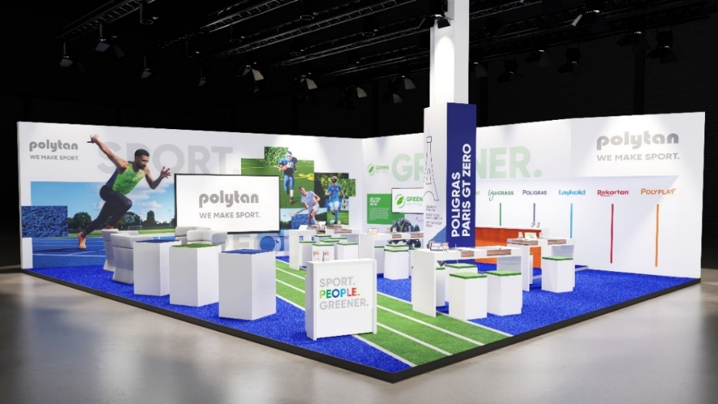
Provisional rendering of this year’s FSB exhibition stand. Polytan’s climate-neutral surface, Poligras Paris GT zero, will be used for the floor of the stand.
Image: Polytan

MakinH FSB

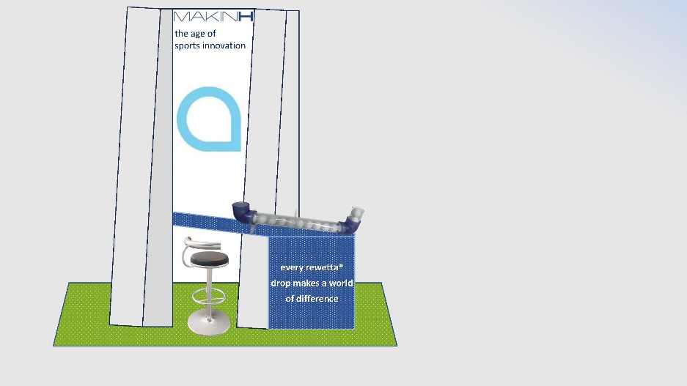
Provisional rendering of this year’s FSB exhibition stand. The recyclable, self-wetting Rewetta® hockey ball and container are shown at the exhibition stand.

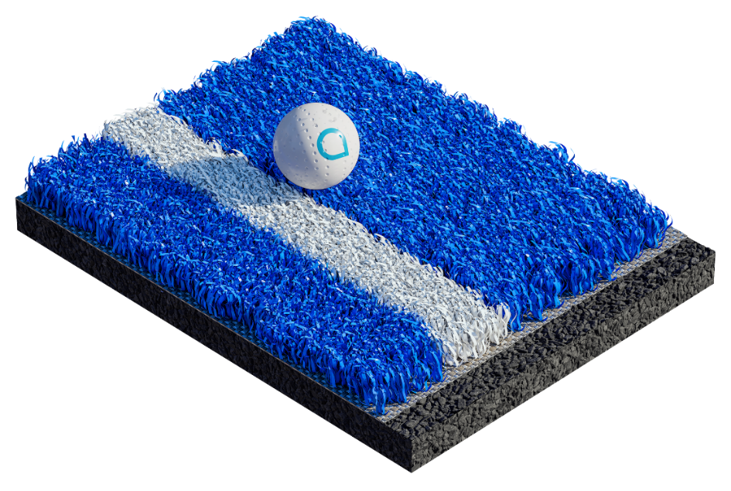
MakinH’s self-wetting Rewetta® hockey ball enables a fast, precise game of hockey, even on unwatered hockey turf.

Image: Polytan GmbH and MakinH BV

About Polytan:

Providing the optimal surface for athletic success – Polytan has pursued this aim with its sports flooring and artificial turf systems since 1969. And the bonus is that sustainability and environmental compatibility have always been a priority for Polytan. The spectrum ranges from environmentally friendly raw materials and energy conservation during the manufacturing processes to the recycling of the surfaces. In line with its motto of “We make sport. Greener.”, Polytan is continuously and effectively improving the future of sports flooring. Polytan’s Green Technology (GT) line is the result of years of research, and signals a new generation of state-of-the-art products and processes that combines specialised expertise with the functional and ecological benefits of renewable raw materials and resource-saving technologies.

Polytan’s portfolio is built for disciplines such as football, hockey, rugby, American football, athletics, tennis and multisport use, and even offers fall-protection options. As well as developing, manufacturing and installing sports surfaces, Polytan also offers line painting, repair, cleaning and maintenance as part of its range of services. Polytan provides the largest sports-surface installation network in Europe, the Middle East, Asia and the Pacific. All products comply with the latest national and international standards, and have all the relevant certifications of international sporting associations, such as FIFA, FIH, World Rugby and World Athletics.

Further information is available online: https://www.polytan.com/ and https://wemakesport.polytan.com/.

About the Sport Group:

The Sport Group sells and installs more synthetic turf pitches, athletics tracks and multifunctional playing fields than any other company worldwide. The Sport Group consists of 21 companies, including Polytan and AstroTurf.

The Sport Group, Polytan and AstroTurf are committed to the long-term health of hockey as a sport. We are partners with many hockey organisations around the world, including the FIH, Asian Hockey Federation, German Hockey Federation, Hockey South Australia, USA Field Hockey, and Catalan Hockey Federation (Spain).

About Poligras:

Poligras is the Sport Group’s global brand for synthetic hockey turf. Poligras Paris GT zero is available worldwide from the companies in the Sport Group: Polytan in EMEA and the Asia-Pacific region, and AstroTurf in the USA and North/South American region.

Agency contact: | Company contact:
Seifert PR GmbH (GPRA) | Polytan GmbH
Clemens Ottmers | Tobias Müller
Zettachring 2a | Gewerbering 3
70567 Stuttgart, Germany | 86666 Burgheim, Germany
+49 (0) 711 / 77918-17 | +49 (0) 8432 / 87-71
clemens.ottmers@seifert-pr.de | tobias.mueller@polytan.com

