Polytan at FSB 2023, 24th–27th October in Cologne

Experience the entire world of sport

In 2023, Polytan will once again make an appearance at the International Trade Fair of Amenity Areas, Sports and Pool Facilities (FSB) in Cologne. This year, German specialist for synthetic turf and sports surfaces will present itself under the slogan: “Sport. People. Greener.” It underlines the company’s strategy to provide sustainable and environmentally friendly products for professional and popular sport in line with its social responsibility.

The company’s steady course towards sustainability will also be reflected in the exhibition concept. At its centre are systems that optimise the sustainability of the synthetic turf and surfaces, which Polytan markets under its “Green Technology” label. This includes the use of biobased plastics, which are used in LigaTurf synthetic turf systems as well as Rekortan running tracks. The sports surface specialist also uses post-consumer recycled (PCR) material in its production – in other words, recycled plastics that have been used before. The LigaTurf Cross GTR even combines both of the above innovations. This means the filaments are made partially of recycled plastic and partially of biobased plastic.

The hockey tournaments at the Olympic Games in Paris will be played on Polytan turf for the ninth time. Accordingly, the synthetic hockey turf systems exhibited in Cologne have a special significance. With Poligras Paris GT zero, Polytan will present the world’s first CO₂-neutral synthetic turf for field hockey, developed specially for Paris 2024. As of recently, the new hockey turf also fulfils the “Dry Hockey” innovation category of the FIH. What’s more, Poligras synthetic turf from Polytan provides the perfect surface for padel, which will be played as an Olympic discipline for the first time in Paris 2024.

In addition to Polytan, other major brands and products in the sports and leisure segment are united under the umbrella of the Sport Group, such as Melos, FormaTurf and SYNLawn. They too will be represented at the trade fair in Cologne, in direct proximity to the Polytan stand. SYNLawn is considered a premium brand for synthetic turf landscaping on the European and American market. With over 200,000 installations in the USA alone, SYNLawn is the industry leader for private and commercial synthetic turf applications. Meanwhile, Melos is a leading manufacture and provider of EPDM granules for sports and leisure surfaces. The 100-percent recyclable solution, as offered by Polytan and FormaTurf, is yet another step towards increasing the sustainability and environmental friendliness of synthetic turf and closing the material cycle.

Through the joint trade fair appearance of the companies in the Sport Group, the closed lifecycle of the respective products will be made visible and explained as needed by experts on site. The proximity of the separate stands will allow visitors to experience the entire world of the Sport Group at once.

Polytan will be exhibiting in Hall 10.2 at Stand E011 from 24th to 27th October.

Image:

Polytan FSB _01

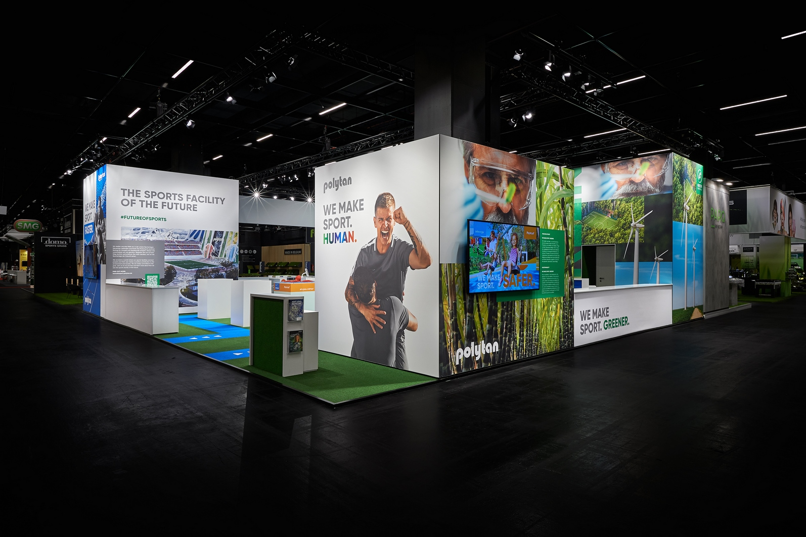

FSB went ahead in 2021, despite the coronavirus pandemic – pictured is the Polytan FSB trade fair stand from 2021.

Photo: Sandra Schuck

About Polytan:

Providing the optimal surface for athletic success – Polytan has pursued this aim with its sports flooring and artificial turf systems since 1969. And the bonus is that sustainability and environmental compatibility have always been a priority for us here at Polytan. The spectrum ranges from environmentally friendly raw materials and energy conservation during the manufacturing processes to the recycling of the surfaces. In line with its motto of “We make sport. Greener.”, Polytan is continuously and effectively improving the future of sports flooring. Polytan’s Green Technology line (GT) is the result of years of research and signals a new generation of state-of-the-art products and processes that combines specialised expertise with the functional and ecological benefits of renewable raw materials and resource-saving technologies.

Polytan’s portfolio is built for disciplines such as football, hockey, rugby, American football, athletics, tennis and multisport, and even offers fall protection. As well as developing, manufacturing and installing sports surfaces, Polytan also offers line painting, repair, cleaning and maintenance as part of its range of services. Polytan provides the largest sports surface installation network in Europe, the Middle East, Asia and the Pacific. All products comply with the current national and international standards, and have all the relevant certifications of international sporting associations, such as FIFA, FIH, World Rugby and World Athletics.

Further information is available online: https://www.polytan.com/ and https://wemakesport.polytan.com/.

About the Sport Group:

The Sport Group sells and installs more synthetic turf pitches, athletics tracks and multifunctional playing fields than any other company worldwide. The Sport Group consists of 21 companies, including Polytan and AstroTurf.

The Sport Group, Polytan and AstroTurf are committed to the long-term health of hockey as a sport. We are partners of the FIH (International Hockey Federation), the Asian Hockey Federation, and many other hockey organisations around the world, including the German Hockey Federation, Hockey South Australia, USA Field Hockey and Catalan Hockey Federation (Spain).

About Poligras:

Poligras is the Sport Group’s global brand for synthetic hockey turf. Poligras Paris GT zero is available worldwide from the companies in the Sport Group: Polytan in EMEA and the Asia-Pacific region, and AstroTurf in the USA and the North/South American region.

Agency contact: | Company contact:
Seifert PR GmbH (GPRA) | Polytan GmbH
Clemens Ottmers | Tobias Müller
Zettachring 2a | Gewerbering 3
70567 Stuttgart, Germany | 86666 Burgheim, Germany
+49 (0) 711 / 77918-17 | +49 (0) 8432 / 87-71
clemens.ottmers@seifert-pr.de | tobias.mueller@polytan.com

