Supporting Athletics in Scotland

Polytan becomes Official Partner of Scottish Athletics

scottishathletics, governing body for athletics in Scotland, and Polytan, a global leader in sports surfacing, is pleased to announce that the company is becoming an official partner of scottishathletics. This exciting partnership aims to promote athletics in Scotland and support the development of world-class athletes.

Having established itself as the Official Sports Surface Partner of England Athletics, Polytan is proud to extend its support to Scotland. The partnership with scottishathletics will enable Polytan to provide its expertise and technology to deliver high-quality sports surfaces for athletics events across Scotland.

As part of this partnership, Polytan is excited to introduce its innovative Polytan SMART technology. All new builds or tracks requiring re-topping or resurfacing will now include a basic Polytan SMART installation. Polytan SMART offers advanced tracking capabilities, enhancing the training and performance analysis for athletes.

Polytan will work closely with partner sports track contractors to carry out the necessary track builds, resurfaces, and re-tops. By collaborating with experienced professionals, Polytan ensures the highest standards of construction and maintenance for athletics tracks in Scotland.

Furthermore, Polytan will introduce its latest Green technology range to Scottish athletics tracks, specifically the Rekortan AS GT. This acrylic-based porous spray system features no fossil fuels, offering an environmentally friendly solution. The GT binder used in the base further enhances sustainability, reflecting Polytan's commitment to eco-friendly practices.

By partnering with scottishathletics, Polytan underscores its commitment to sport and talent development. The company will work closely with scottishathletics to offer training programs and support for clubs and athletes at all levels. This partnership is a significant step towards strengthening athletics in Scotland and improving the infrastructure for future sports events.

"We are thrilled to become an official partner of scottishathletics," said Ashley Appleby, Sales Manager UK at Polytan. "Athletics has a long and successful tradition in Scotland, and we look forward to contributing to its continued legacy. By providing high-quality sports surfaces and supporting athlete development, we aim to help Scotland achieve further success on the international stage."

scottishathletics welcomes the partnership with Polytan and the innovative offerings it brings. "The inclusion of Polytan SMART and the introduction of the Green technology range to our athletics tracks will undoubtedly benefit our athletes and enhance their training experience," said Colin Hutchison, chief executive of scottishathletics. "We appreciate Polytan's commitment to sustainable solutions and look forward to the positive impact this partnership will have on our sport."

Images:

Polytan Official Partner of scottishathletics_01
The first projects of scottishathletics‘ new partner have already been realised in at the Riverside Sports Arena in Ayr.
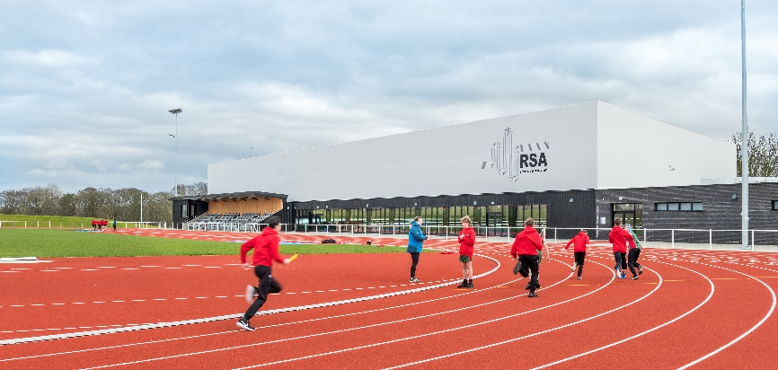

Foto: Polytan – Chris Humphreys

Polytan Official Partner of scottishathletics_02
The reference project in Ayr includes both outdoor and indoor sports facilities.
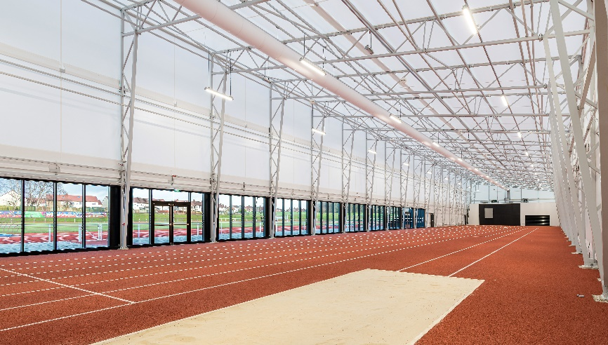

Foto: Polytan – Chris Humphreys

About scottishathletics:
scottishathletics (Scottish Athletics Ltd) is the National Governing Body for Athletics in Scotland. A company limited by guarantee (established 2001), scottishathletics is affiliated to UK Athletics, which is in turn affiliated to World Athletics.

It is in practice an organisation made up of its member clubs. There are approximately 150 athletics clubs across Scotland – offering opportunities for people of all ages to try out, train, embrace and compete in the various disciplines of athletics – and at all levels from jogging to Olympic and Commonwealth Games levels.

About Polytan:

Providing the optimal surface for athletic success – Polytan has pursued this aim with its sports flooring and artificial turf systems since 1969. And the bonus is that sustainability and environmental compatibility have always been a priority for us here at Polytan. The spectrum ranges from environmentally friendly raw materials and energy conservation during the manufacturing processes to the recycling of the surfaces. In line with its motto of “We make sport. Greener.” Polytan is continuously and effectively improving the future of sports flooring. Polytan’s Green Technology line (GT) is the result of years of research and signals a new generation of state-of-the-art products and processes that combines specialised expertise with the functional and ecological benefits of renewable raw materials and resource-saving technologies.
Polytan’s portfolio is built for disciplines such as football, hockey, rugby, American football, athletics, tennis and multisports, and even offers fall protection. As well as developing, manufacturing and installing sports surfaces, Polytan also offers line painting, repair, cleaning and maintenance as part of its range of services. Polytan provides the largest sports surface installation network in Europe, the Middle East, Asia and the Pacific. All products comply with the current national and international standards, and have all the relevant certifications of international sporting associations, such as FIFA, FIH, World Rugby and World Athletics.

Find more information at: https://www.polytan.com/ und https://wemakesport.polytan.com/.

Company Contact:
Polytan GmbH
Tobias Müller
Gewerbering 3
86666 Burgheim
08432 / 87-71
tobias.mueller@polytan.com

