Socca World Cup in Lisbon
Polytan synthetic turf for small-sided football World Cup
It’s a truism that after every world championship the focus is on the next. The same applies for football. But it would be a mistake to think of 2022 and Qatar already. Because the next World Cup is happening at the end of September – and it will be held in Lisbon. The Portuguese capital will play host to 32 teams from around the world as they battle it out for the biggest title in small-sided football. The venue for the Socca World Cup is the stadium in the Praça do Comércio, which has been built specially for this event. This square marks the centre of the vibrant capital city and is where all the matches in the tournament will be held.
Germany's national team will also be in on the action under the excellent leadership of national coach Malte Froehlich and assistant coach Sebastian Maak. The games will be played just like the "big ones": the group stage consists of eight groups, each with four teams. The teams all play each other with the aim of finishing in the top two of each group to reach the last sixteen. They then move on to the knockout stage to try and make it to the final on 29 September 2018. The German team's first opponent is India, followed by Croatia and Angola. The games are played on a half-size pitch – and on synthetic turf from Polytan.
Polytan has created the "LigaTurf Socca" playing surface in conjunction with the International Socca Federation (ISF) specifically for this major event. This synthetic turf is custom-made and has smooth and textured filaments like the LigaTurf Cross system, although in this case they are green and blue. And this surface is likewise extremely robust and easy to maintain. Friedemann Söll, Head of Product Management & Marketing at Polytan, comments on "LigaTurf Socca": "We are proud that our latest technological advances enable us to contribute to an event that brings so much pleasure to people across the world. Events of this kind show that sports events are moving increasingly from out-of-town stadiums into the inner cities and the big squares where they can reach spectators on an emotional level. We provide easy-to-install, temporary systems to cater for this clearly identifiable trend so that professional sport can be practised in such venues as well. And, needless to say, we are also taking the opportunity to demonstrate the numerous attributes of synthetic turf systems in Lisbon in conjunction with our partner ISF."
Shahzeb Trunkwala, Vice-President of the ISF, emphasised the fact that its partnership with Polytan is set to continue after the current World Cup and into the future. Christoph Koechy, who manages all the sponsorship activities around the World Cup, believes he is receiving the best possible support from Polytan and the "very best artificial turf you can get anywhere".
www.polytan.com

Captions:
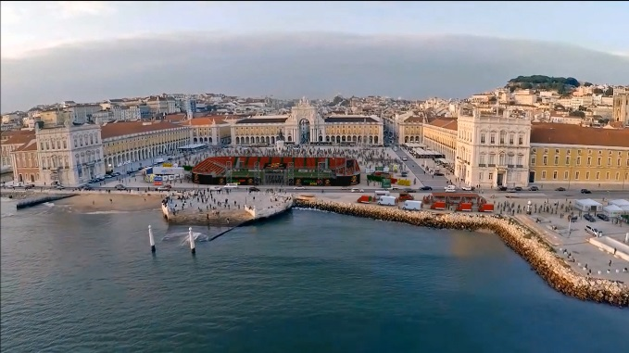
Socca-World-Cup-01.jpg (Photo: International Socca Federation)
The venue for the Socca World Cup is the stadium in the Praça do Comércio, which has been built specially for this event. This is where all the matches in the tournament will be held – on synthetic turf from Polytan.
.

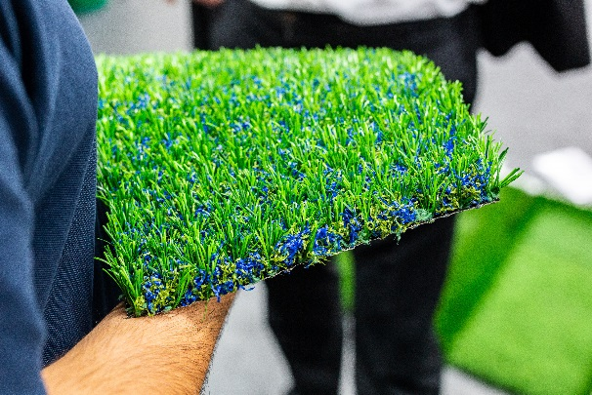
Socca-World-Cup-02.jpg (Photo: Tim Ahlrichs)
Polytan has created the "LigaTurf Socca" playing surface specifically for this major event. This synthetic turf is custom-made with smooth and textured filaments.

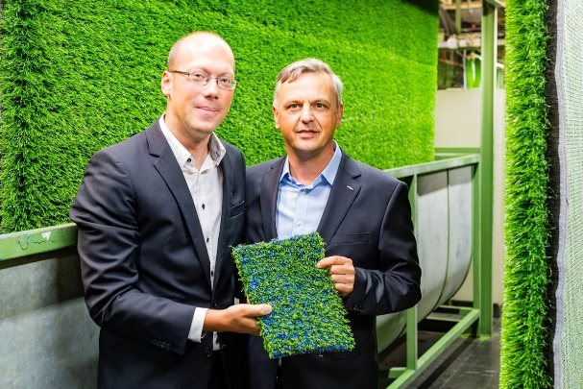
Socca-World-Cup-03.jpg (Photo: Tim Ahlrichs)
Christoph Koechy, who manages all the sponsorship activities around the World Cup, and Markus Deimling, CEO Polytan GmbH, are proud to contribute to an event that brings so much pleasure to people across the world with "LigaTurf Socca".

Polytan GmbH:
To make the optimal surface for sporting success – that has been the ideal pursued by Polytan since 1969. With a constant eye on the latest findings in the field of sports medicine, the specialist in outdoor sports surfaces is continuously refining its synthetic surfaces and synthetic turf systems. Today's synthetic turf pitches not only feel like real grass, for example, they also have excellent playing qualities. High-quality synthetic surfaces now range from shock-absorbing soft-impact surfaces and multi-functional all-weather pitches all the way to high-speed surfaces for international athletics events. As well as developing, manufacturing and fitting its own sports surfaces, the spectrum of services provided by Polytan also includes line markings, repairs, cleaning and maintenance. All products meet current national and international standards and are duly certified by international sports federations such as FIFA, FIH, World Rugby and IAAF.

Agency contact:
Seifert PR GmbH (GPRA)
Barbara Mäurle
Zettachring 2a
70567 Stuttgart
0711 / 77918-26
barbara.maeurle@seifert-pr.de

Company contact:
Polytan GmbH
Tobias Müller
Gewerbering 3
86666 Burgheim
08432 / 8771
tobias.mueller@polytan.com

