Colourful outdoor space design in the Unterschleißheim secondary school:
Orange and green in harmony
“More beautiful, colourful and modern” than the previous structure – that's how the replacement building of the Therese Giehse secondary school is described in the construction diary on the school’s website. The educational facility in Unterschleißheim, which entered use in September 2016, is extraordinarily colourful not only on the façade, but also in the outdoor area, where the colours of the synthetic surfaces in the courtyard pick up on the orangey green design concept of the building shell. Both the multipurpose pitch and three seating areas and the soft-impact surface under the climbing frame comprise synthetic surfaces from Polytan – the weather-resistant material dries out quickly and is pleasant to the touch throughout the year, according to the landscape architect responsible.
The competition for the new building was won by Diezinger Architekten from Eichstätt, while Munich landscape architects Adler & Olesch were responsible for designing the outdoor facilities. Planning began in 2013 and the new building was ready for occupation punctually for the start of the 2016/17 school year. The outdoor facilities, completed in July 2017, now stand where the old building used to be.
As part of the revamp of the outdoor area, the school’s management wanted not only a multipurpose pitch but also facilities for other games and sports such as table tennis, streetball and a climbing frame. Today the installations also include hopping boards and three organically shaped seating areas. These are available to the students both in breaks between classes and in their free time. The students of the neighbouring Carl Orff grammar school can also make use of them. A “green classroom” has been built on the rear of the new building as well.
When it came to the surface of the multipurpose pitch and of the additional sports and playing areas, the landscape architects opted for the PolyPlay S synthetic surface from Polytan. The bold orange shade of the surface picks up on the orange-green design concept of the façade as well as the green seating areas and the green soft-play surface under the climbing frame.
The PolyPlay S synthetic surface is a long-lasting, all-round sports surface that has a smooth yet non-slip surface and offers good ball bounce behaviour, making it ideal for school sports facilities. The managing director of Munich-based landscape architects Adler & Olesch, Ulrike Tuchnitz, also appreciates the water permeability, look and feel of the material: “The surface dries off quickly after rain, it's not too hot in summer and not too cold in winter.” To ensure the whole courtyard looks more or less like a single piece – “without an ugly mix of materials”, says the planner –, the three organically shaped seating areas likewise consist of the easy-care, weather-resistant PolyPlay S in May green. The seating areas cover an area of over 200 m² in the courtyard and are 49 centimetres high – safety railings would have been required from half a metre.
Because of the increased risk of injury, the synthetic surface underneath the climbing frame is designed as a shock-absorbent PolyPlay FS soft-impact surface. This Polytan product – like the PolyPlay S – consists of two layers, with the top layer made of EPDM granules (rubber). The second, supporting layer is made of recycled materials and provides the requisite elasticity. The thickness of the base layer varies between 30 and 115 mm, depending on the critical drop height from the play equipment. There are soft-impact surfaces up to a drop height of 3 m, with a handrail required by law above this.
Further information about synthetic surfaces from Polytan can be found at www.polytan.com.
CONSTRUCTION SITE SIGN:
Client: Zweckverband Staatliche weiterführende Schulen in
Unterschleißheim, Unterschleißheim
Building planning: Diezinger Architekten GmbH, Eichstätt office
Outdoor facilities planning: Adler & Olesch Landschaftsarchitekten München GmbH
Outdoor facilities project management: Dorothee Gerstner and Ulrike Tuchnitz
Building completed: September 2016
Outdoor facilities completed: July 2017
Polytan products used:
Multipurpose pitch + outdoor area: 1,881 m² PolyPlay S in orange
Seating areas: 202 m² PolyPlay S in May green
Climbing frame soft-impact surface: 151 m² PolyPlay FS in May green

Captions: (Photographs: Polytan / Tobias Müller)
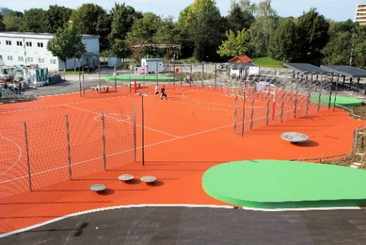
Polytan_Realschule_Therese-Giehse_1.jpg
The multipurpose pitch is the heart of the new outdoor facilities. It is not the usual strict rectangle, its organic shapes instead forming flowing transitions to the green seating areas of the facility.

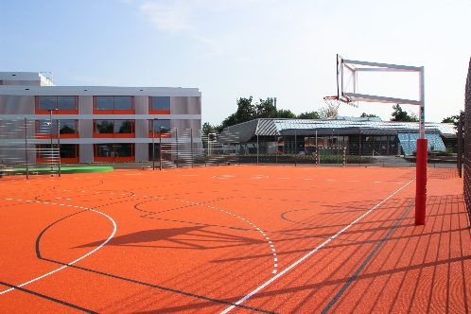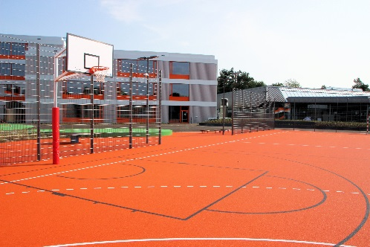
Polytan_Realschule_Therese-Giehse_2_3.jpg
The old building used to stand where the students of the Therese Giehse secondary school now kick balls and charge around.
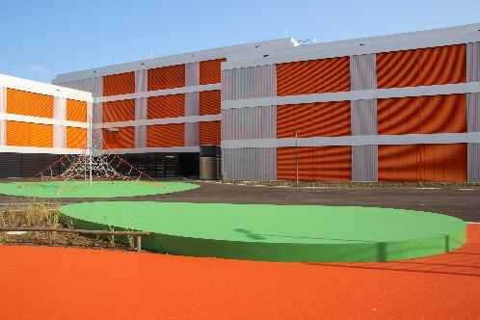 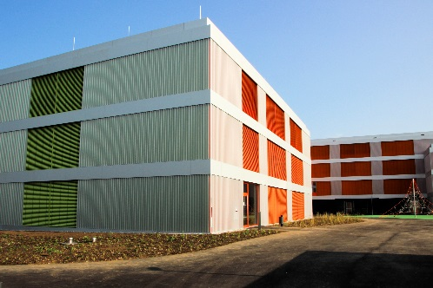
Polytan_Realschule_Therese-Giehse_4_5.jpg
The landscape architects took the bold green and orange colours of the new surfaces in the courtyard from the façade design of the new building.

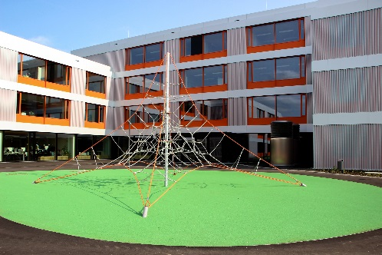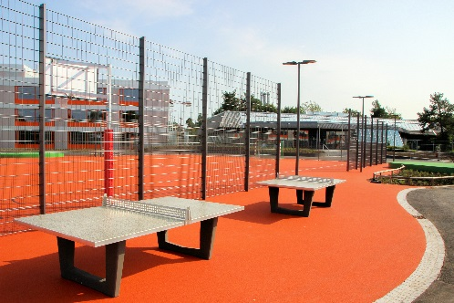
Polytan_Realschule_Therese-Giehse_6_7.jpg
A May green PolyPlay FS surface from Polytan was installed to provide a soft impact under the climbing frame. The table tennis tables, on the other hand, stand on a PolyPlay S in orange.

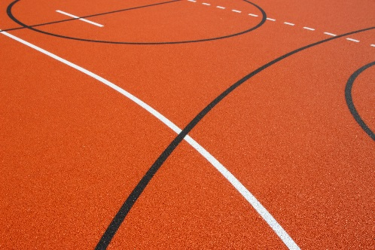
Polytan_Realschule_Therese-Giehse_8.jpg
The easy-care, all-round PolyPlay S is a smooth sports surface with good ball bounce behaviour, yet non-slip.
Polytan GmbH:
To make the optimal surface for sporting success – that has been the ideal pursued by Polytan since 1969. With a constant eye on the latest findings in the field of sports medicine, the specialist in outdoor sports surfaces is continuously refining its synthetic surfaces and synthetic turf systems. Today's synthetic turf pitches not only feel like real grass, for example, they also have excellent playing qualities. High-quality synthetic surfaces now range from shock-absorbing soft-impact surfaces and multi-functional all-weather pitches all the way to high-speed surfaces for international athletics events. As well as developing, manufacturing and fitting its own sports surfaces, the spectrum of services provided by Polytan also includes line markings, repairs, cleaning and maintenance. All products meet current national and international standards and are duly certified by international sports federations such as FIFA, FIH, World Rugby and IAAF.

Agency contact:
Seifert PR GmbH (GPRA)
Barbara Mäurle
Zettachring 2a
70567 Stuttgart
0711 / 77918-26
barbara.maeurle@seifert-pr.de

Company contact:
Polytan GmbH
Tobias Müller
Gewerbering 3
86666 Burgheim
08432 / 8771
tobias.mueller@polytan.com

