Optimal preparation for sprinter Amelie-Sophie Lederer:
Off to the London WC with Polytan SmarTracks
The World Championships in Athletics will be held in London in August. Also taking part will be 71 athletes from the German Athletics Federation (Deutscher Leichtathletik-Verband - DLV), including Amelie-Sophie Lederer. The new Bavarian record holder over 100 metres has been selected by the DLV for the 4x100 metres relay. A key factor in her current success is the improved training conditions at her home club, LAC Quelle Fürth, where the 23-year-old athlete and police officer has been preparing for her events with the
Polytan SmarTracks system since April. This precision data logging system facilitates professional training diagnostics without complex technical equipment in or on the track. Polytan will be presenting the system to the industry at "IAAF Athletics Connect 2017" in London on 2 August – including a live demonstration on a mobile running track with a Rekortan M synthetic surface.
The new Bavarian record holder achieved her personal best of 11.28 seconds over 100 metres in the run-up to the German Championships in Erfurt on 8 July, putting coach Helmut Vetter's protégé in fifth place in the women's outdoor rankings in Germany. She finished in sixth place in the final with a time of 11.47 seconds. The performance of this elite athlete has steadily improved since May: she ran a time of 11.50 seconds over 100 metres in the Bayerncup (Bavaria Cup) in Erding at the end of May, for example, but was a whole tenth of a second faster at the Sparkassen-Gala in Regensburg by the middle of June. Amelie-Sophie Lederer attributes her success partly to the improved training conditions with Polytan SmarTracks: "I am very pleased that Polytan has provided us with modern sensor technology. It's an ideal way for me to prepare for the World Championships in London."

Coach Helmut Vetter particularly appreciates the detailed digital assessments: "The system makes it possible to do a comprehensive training analysis, even with several athletes at the same time and under competition conditions."
In contrast to other time recording systems such as photoelectric sensors or GPS, Polytan SmarTracks can also be used to measure step length and frequency. What is more, the data can be automatically evaluated – a real asset in a training routine. The movement data are captured by magnetic timing gates in the ground and the sensor worn on the body, which weighs just 24 g. This is made possible by humotion's highly developed sensor technology with three-dimensional data capture, which actually consists of a number of intelligent individual sensors rather than a single one.
Two round magnetic elements are sunk into the ground at intervals of 1.0-1.30 m, each forming a timing gate. Polytan recommends a minimum distance of 3 m between the timing gates in the running direction. The fact that the technology is in the ground out of sight ensures full protection against vandalism and any kind of weather while at the same time eliminating the time required for setting up and dismantling technical equipment before and after training.
The first reference project with SmarTracks technology was completed in Osnabrück in August 2008 – and by the end of this year it will already be installed in 20 athletics facilities in Germany and in another one in Great Britain.
The live demo at "IAAF Athletics Connect 2017" (www.athleticsconnect.org) in London on 2 August will be another opportunity to significantly raise the international profile of the system worldwide. According to Polytan Managing Director Markus Deimling: "In London we will be presenting the pioneering sensor technology in combination with our well-known professional sports surface Rekortan M, on which countless records and personal bests have been set at international track and field athletics meetings such as the IAAF Diamond League."
Captions:
Lederer_Amelie_06.jpg (Photo: Kiefner Sportfoto)
Amelie-Sophie Lederer at the Sparkassen-Gala in Regensburg in June, where she won the 100 metre sprint in 11.40 seconds. Since April the successful athlete has been using Polytan SmarTracks to prepare for the WC in London, for which she has been selected by the DLV for the 4x100 metres relay.
Lederer_Amelie_02.jpg (Bildnachweis: Kiefner Sportfoto)
Amelie-Sophie Lederer in July at the German Championships in Erfurt, where she was able to improve her personal best to a sensational 11.28 seconds in the run-up to the 100 metre sprint.
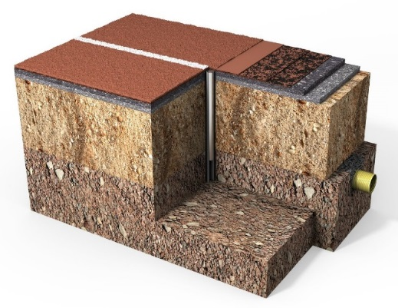
Polytan_SmarTracks_2.jpg (picture credit: Polytan)
Structure of a multi-layered solid synthetic surface from Polytan with magnetic timing gate buried in the ground out of sight.

Polytan GmbH:
To make the optimal surface for sporting success – that has been the ideal pursued by Polytan since 1969. With a constant eye on the latest findings in the field of sports medicine, the specialist in outdoor sports surfaces is continuously refining its synthetic surfaces and synthetic turf systems. Today's synthetic turf pitches not only feel like real grass, for example, they also have excellent playing qualities. High-quality synthetic surfaces now range from shock-absorbing soft-impact surfaces and multi-functional all-weather pitches all the way to high-speed surfaces for international athletics events. As well as developing, manufacturing and fitting its own sports surfaces, the spectrum of services provided by Polytan also includes line markings, repairs, cleaning and maintenance. All products meet current national and international standards and are duly certified by international sports federations such as FIFA, FIH, World Rugby and IAAF.

Agency contact:
Seifert PR GmbH (GPRA)
Barbara Mäurle
Zettachring 2a
70567 Stuttgart
0711 / 77918-26
barbara.maeurle@seifert-pr.de

Company contact:
Polytan GmbH
Tobias Müller
Gewerbering 3
86666 Burgheim
08432 / 8771
tobias.mueller@polytan.com

