Eco-friendly rehabilitation of synthetic surfaces
Re-topping: putting a new gloss on old tracks
A time-saving and eco-friendly option for making running tracks that are showing their age as good as new again is to have the synthetic surface professionally re-topped. This entails laying a new wear layer on top of the existing installation – so there is no need to excavate and dispose of the old material. In its portfolio Polytan has two re-topping products that can be installed on any existing surface: Rekortan M RT, the water-impermeable system coated in situ, and Spurtan WS RT, the structural system that is permeable to water. One is a PUR coating with strewn EPDM granules, the other a spray coating.
Running tracks with elastic synthetic surfaces such as we know them today have been the only acceptable surface for athletics events at elite level since the Olympic Games in Mexico in 1968. The functional qualities they provide for sport, such as energy enhancement and shock absorbency, mean they are now part and parcel of modern sports facilities – whether the running tracks are for schoolchildren, amateur or professional athletes.
Intensity of use and type of system determine the useful life
The useful life of a synthetic surface generally varies between 10 and 30 years, depending on the intensity of use and the type of system that is installed. In principle, a surface that is coated or poured in situ (also called a solid synthetic surface) is much more hard-wearing and long-lasting than a structured surface (sometimes referred to as a spray coating or spray surface). Since spray coatings have a thinner wear layer than products poured or coated in situ, they wear out much sooner due to the effect of spikes, for instance. In addition to abrasion, the running tracks harden over time and become brittle – an ageing process of synthetic floors that occurs relatively quickly in the case of prefabricated strips. Polytan's product range includes only synthetic surfaces that are installed in situ in liquid form, allowing them to be optimally adapted to the local circumstances.
The condition of the old surface is the decisive factor
Whether re-topping makes sense will depend on the condition of the existing running track. This is determined in a defined test procedure in which variables such as shock absorption and tensile strength are analysed alongside the evenness of the surface and the general condition of the substrate. If the re-topped track is to be certified as meeting the requirements for international competition laid down by the IAAF, the governing body of world athletics, the inspection is much more intensive than if the aim is merely to refresh the look of the track. For successful re-topping it is immaterial what method of construction was used for the initial installation, whether it was laid in situ or as prefabricated strips, or who the original manufacturer was: the cost of rehabilitation is determined only by its condition.
If the substrate is suitable for re-topping, the old surface is first cleaned thoroughly and any damaged areas are improved. The next stage is – if necessary – to adapt the existing sports equipment, such as the sandpit for the long jump, to the higher level of the future surface. The third and final stage is the actual re-topping process. This is when a new wear layer is laid seamlessly on the existing old surface, optionally as a PUR coating with strewn EPDM granules or as a spray coating. Once hardened, the rehabilitated running track can no longer be distinguished from a new installation.
The Rekortan M RT (PUR coating) and Spurtan WS RT (spray coating) re-topping systems from Polytan can be used on tracks that are permeable to water as well as those that are impermeable. Both rehabilitation solutions have structured surfaces, are suitable for spikes and therefore offer the optimum base for professional applications.
Anyone interested in finding out more can visit www.polytan.de.

Picture credits: (Photos. all: Ben Wiesenfarth / Polytan GmbH)
Before: After:
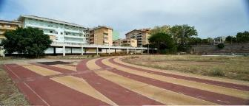 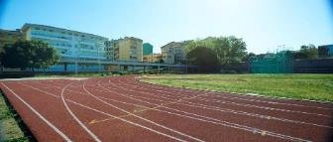
Polytan_Sassari_01_before.jpg Polytan_Sassari_01_after.jpg
Before: After:
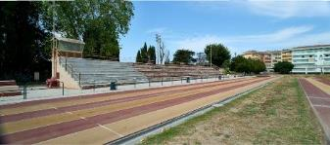 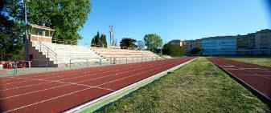
Polytan_Sassari_02_before.jpg Polytan_Sassari_02_after.jpg
The Stadio dei Pini "Tonino Siddi" in Sassari on Sardinia was re-topped by Polytan earlier in the year. The synthetic surface originally laid as prefabricated mats was coated in situ with the Rekortan M RT water-impermeable re-topping system from Polytan.

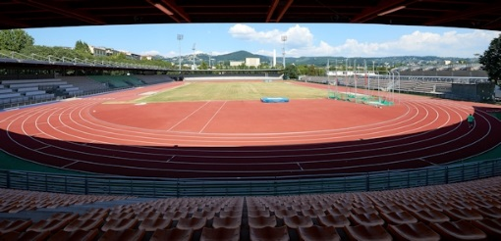 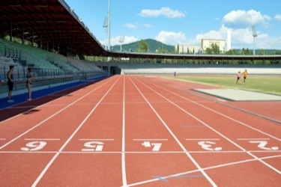
Polytan_Florenz_01.jpg Polytan_Florenz_02.jpg
The old synthetic surface of prefabricated mats in the Stadio Luigi Ridolfi in Florence had been showing its age and was professionally re-topped by Polytan in June 2016. The choice of new coating fell on the Rekortan M RT system, which was coated in situ and optimally adapted to the local circumstances.
Polytan GmbH:
To make the optimal surface for sporting success – that has been the ideal pursued by Polytan since 1969. With a constant eye on the latest findings in the field of sports medicine, the specialist in outdoor sports surfaces is continuously refining its synthetic surfaces and synthetic turf systems. Today's synthetic turf pitches not only feel like real grass, for example, they also have excellent playing qualities. High-quality synthetic surfaces now range from shock-absorbing soft-impact surfaces and multi-functional all-weather pitches all the way to high-speed surfaces for international athletics events. As well as developing, manufacturing and fitting its own sports surfaces, the spectrum of services provided by Polytan also includes line markings, repairs, cleaning and maintenance. All products meet current national and international standards and are duly certified by international sports federations such as FIFA, FIH, World Rugby and IAAF.

Agency contact:
Seifert PR GmbH (GPRA)
Barbara Mäurle
Zettachring 2a
70567 Stuttgart
0711 / 77918-26
barbara.maeurle@seifert-pr.de

Company contact:
Polytan GmbH
Tobias Müller
Gewerbering 3
86666 Burgheim
08432 / 8771
tobias.mueller@polytan.com

