Sustainable, dynamic and faster than ever:
The sustainable turf revolution in hockey
Polytan brought a new hockey turf system to market just in time for FSB 2017 in Cologne. The unfilled Polytan Poligras Tokyo GT is the result of continuous advances in the successful Poligras Platinum, the hockey turf used at the Rio Olympic Games in 2016. This impressive new product allows games to move at an even faster pace. Its filaments are made from over 60 per cent renewable raw materials for the first time – which means that Polytan has managed to bring about a "sustainable revolution" in hockey. This is also reflected in the product name: GT stands for Green Technology and alludes to the product's particularly high level of sustainability and environmental compatibility. Moreover, as a global supplier to the FIH, the Burgheim-based sports surface specialist is the exclusive supplier of hockey turf for the 2018 and 2022 Hockey World Championships and for the 2020 Olympics.
The material used to produce the filaments in the new Polytan Poligras Tokyo GT hockey turf is a BioBased PE, with over 60 per cent of it consisting of a natural raw material. The turf construction has been optimally adapted to the environmentally friendly material to produce an even, multidirectional surface for extremely dynamic and accurate play. The surface is also faster than ever before: Polytan has succeeded in increasing the rolling distance of the ball on Polytan Poligras Tokyo GT by another 25 per cent compared with Poligras Platinum, its predecessor.
The synthetic turf is durable, stable and protected against premature wear and tear thanks to the patented ENTANGLEMENT technology. This special interlacing of molecule chains prevents the narrow edges of pitches from splitting, which is otherwise a common occurrence. The synthetic turf becomes tougher and more robust in spite of a softer PE formulation. What is more, the CoolPlus technology provides for pleasant temperatures on the playing field on hot match days as the infrared rays of the sun, which are responsible for producing heat, are reflected by pigments placed on the surface of the fibres.
Last but not least, PreciTex technology is responsible for the precision-controlled crimping of the textured fibres during the manufacturing process. The result is a multidirectional, tightly sealed surface with optimal ball rolling behaviour which supports the cooling effect of the CoolPlus function at the same time. Further information at www.polytan.com
Captions:
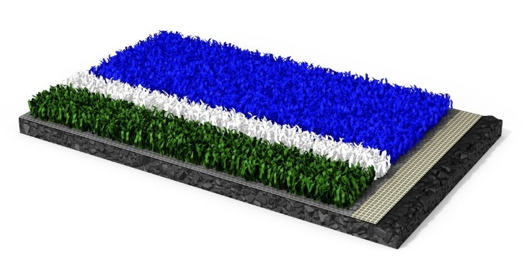
Polytan_Poligras_Tokyo GT.jpg (photo: Polytan)
The new hockey turf Polytan Poligras Tokyo GT impresses both with its excellent playing qualities and its environmental compatibility: the proportion of renewable raw material in the filaments is more 60 per cent for the first time.
Polytan_GT_Green_Technology.jpg (photo: Polytan)
All Polytan products noted for their sustainability are marked with the new GT Green Technology label.

Polytan GmbH:
To make the optimal surface for sporting success – that has been the ideal pursued by Polytan since 1969. With a constant eye on the latest findings in the field of sports medicine, the specialist in outdoor sports surfaces is continuously refining its synthetic surfaces and synthetic turf systems. Today's synthetic turf pitches not only feel like real grass, for example, they also have excellent playing qualities. High-quality synthetic surfaces now range from shock-absorbing soft-impact surfaces and multi-functional all-weather pitches all the way to high-speed surfaces for international athletics events. As well as developing, manufacturing and fitting its own sports surfaces, the spectrum of services provided by Polytan also includes line markings, repairs, cleaning and maintenance. All products meet current national and international standards and are duly certified by international sports federations such as FIFA, FIH, World Rugby and IAAF.

Agency contact:
Seifert PR GmbH (GPRA)
Barbara Mäurle
Zettachring 2a
70567 Stuttgart
0711 / 77918-26
barbara.maeurle@seifert-pr.de

Company contact:
Polytan GmbH
Tobias Müller
Gewerbering 3
86666 Burgheim
08432 / 8771
tobias.mueller@polytan.com

