Open spaces show off the company's know-how
A running track as a central design theme
The ground-breaking ceremony for the head office extension was held in Burgheim on 9 September 2016. Around 50 employees of SportGroup Holding and Polytan were able to move into the new premises right on schedule back in April 2017. A total of 80 people are employed at the site. The sustainable timber-frame construction is made from industrially prefabricated system elements and was designed by the Munich-based architectural practice jürgensarchitekten, with Natalie Jürgens as project manager. Both the elegant, energy-efficient new building and the existing ones are supplied from renewable energy sources. The new geothermal plant saves on resources by using groundwater for heating and cooling.
The new building boasts an office environment designed for ease of communication, a showroom for products and applications, and a break room with access to the garden.
The outdoor space, designed by the Munich-based landscape architects liebald + aufermann, is also used as an extended presentation area. Completed in August, the open-air areas visualise the core expertise of the company without resorting to covering over public space with some sample surfaces.
The landscape architects opted for a red track as the central design theme, since every visitor establishes an association with this product. The track serves as an access route to the new main entrance, where the colour changes to light grey and the line markings go in a different direction. It leads on to a mini-pitch for employees and visitors, where it finishes with two undulating sections. The familiar motif also varies in some places, the effect of which is to leave visitors bemused, alert or, in the best case, entertained. The variety of colours and uses for synthetic surfaces are shown by a "milestone" marker every 10 metres, which will be added later: it is a seating bollard that is covered with a coloured synthetic surface while illuminating the track at the same time. Another special feature is the SmarTracks timing and data logging system, which is embedded in the track and has magnetic timing gates out of sight in the ground.
The landscape architects also took care to match up the colours of the plants in the herbaceous border running alongside the track: perennials have been planted in shades of red and crimson to blend in with the shrubs and prairie grasses. There are also two birch trees with red leaves to mark the main access to the road.
Picture credits, all: Andreas Keller
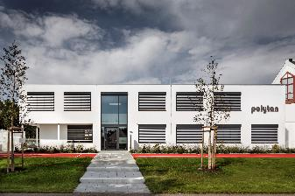 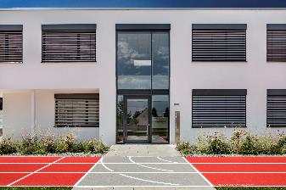
neubau_burgheim_24.jpg neubau_burgheim_62.jpg
The path to the new main entrance. The red track is intersected by a light grey surface with line markings going in a different direction.
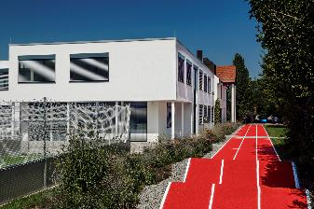 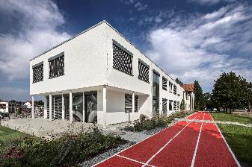
neubau_burgheim_61.jpg neubau_burgheim_08.jpg
The track ends at the mini-pitch with two gentle undulations – a large terrace for visitors and staff is also situated here.
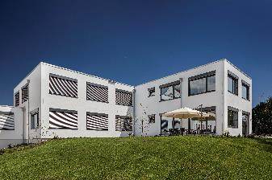 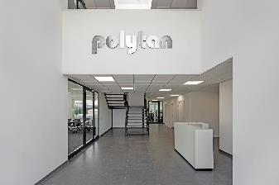
neubau_burgheim_17.jpg neubau_burgheim_13.jpg
Rear of building with another terrace and the reception area inside the building.
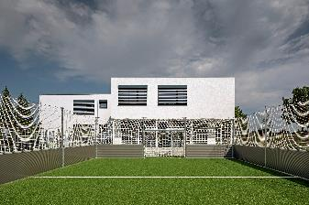 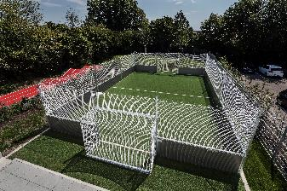
neubau_burgheim_09.jpg neubau_burgheim_64.jpg
A mini-pitch is situated at the end of the track so visitors and staff can enjoy a kickabout whenever they feel like it.

Polytan GmbH:
To make the optimal surface for sporting success – that has been the ideal pursued by Polytan since 1969. With a constant eye on the latest findings in the field of sports medicine, the specialist in outdoor sports surfaces is continuously refining its synthetic surfaces and synthetic turf systems. Today's synthetic turf pitches not only feel like real grass, for example, but they also have excellent playing qualities. High-quality synthetic surfaces now range from shock-absorbing soft-impact surfaces and multi-functional all-weather pitches all the way to high-speed surfaces for international athletics events. As well as developing, manufacturing and fitting its own sports surfaces, the spectrum of services provided by Polytan also includes line markings, repairs, cleaning and maintenance. All products meet current national and international standards and are duly certified by international sports federations such as FIFA, FIH, World Rugby and IAAF.

Agency contact:
Seifert PR GmbH (GPRA)
Barbara Mäurle
Zettachring 2a
70567 Stuttgart
0711 / 77918-26
barbara.maeurle@seifert-pr.de

Company contact:
Polytan GmbH
Tobias Müller
Gewerbering 3
86666 Burgheim
08432 / 8771
tobias.mueller@polytan.com

