Polytan Arena with TÜV-tested safety standards:
Small on space, big on fun
The German Football Association (DFB) has seen miniature soccer pitches being built nationwide since 2008 as a result of its "1,000 mini-pitches for Germany" campaign. The idea was to follow up the FIFA World Cup in Germany with a sustainable scheme to develop the talents of young footballers. This unique campaign, in which Polytan is an official project partner and general contractor, has been a long-running success story: the Burgheim-based sports surface specialist is extremely successful at designing and installing mini-pitches all over the world today. These have since matured into the Polytan Arena, a multipurpose integrated system. The version with a solid foundation carries the TÜV Süd GS quality seal.
Conventional mini-pitches are the perfect combination of fun and football, as all age groups can use them for a kickabout whenever they feel like it. They are as popular among clubs as they are in schools or in public grounds. The typical DFB mini-pitch measures 20 x 13 m and consists of a playing surface with synthetic turf, two goals, a fence surround and high ball stop netting. They generally have solid foundations below the fence surround system and an elastic layer which is easy on the joints and protects players from injury. Side and roof nets can be added if required.
Polytan Arena – Quality from a single source
The popular Polytan football courts were first developed in 2008 and have been continuously improved ever since. They are now available as multi-use Polytan Arenas in numerous designs for various kinds of sport. They come in the standard sizes of 15 x 10 m, 20 x 13 m, 30 x 15 m and 40 x 20 m or can be custom-built to cater for individual requirements. Not only can they be installed with solid foundations, there is also a mobile version which can be laid on existing sports surfaces. The textured LigaGrass Pro CoolPlus synthetic turf has proven its worth as a playing surface for mini football pitches: while it is highly resilient, its soft filaments are also ideally suited to young football players. The environmentally friendly infill consists of EPDM rubber granules and it is responsible for the necessary grip as well as the natural grass look and the permanently high elasticity. Alternatively, a Polytan Arena can also be fitted with a water-permeable PolyPlay S synthetic surface – so the idea of mini pitches can also be transferred to other types of sport such as basketball, handball, badminton, volleyball and hockey. A wide selection of optional extras, including basketball hoops and volleyball nets, can be supplied for this purpose. The fence surround system is available in four different metallic colours or in special colours on request.
Polytan designed the standardised mini-pitch system with flexibility in mind: all the components of a Polytan Arena can be subsequently changed or replaced. The range of products also includes anti-vandal systems and noise-reducing fence surrounds.
All Polytan mini-pitches and Polytan Arenas comply with DIN EN 15312 for freely accessible multi-sport equipment. As a complete system, they are supplied from a single source – including installation and maintenance service – so they can be relied on to meet the highest requirements in terms of quality, safety and functionality. What's more, the courts with solid foundations carry the GS mark awarded by TÜV Süd as a guarantee of the best possible level of safety.

Captions:
TÜV SÜD_GS Zeichen.png
Polytan Arenas with solid foundations meet the highest safety requirements. They have also been awarded the GS mark by TÜV SÜD for tested safety.
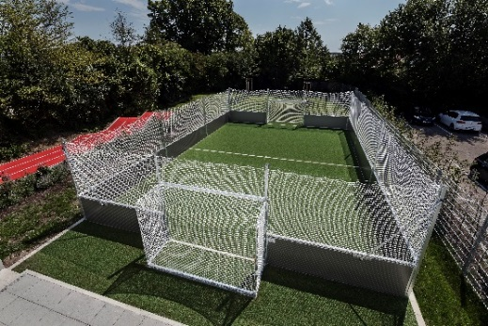
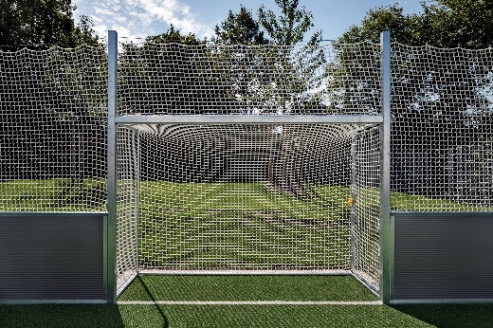
Polytan PolyPlay Arena 01+02.jpg
Today Polytan supplies mini-pitches as Polytan Arenas, multipurpose integrated systems from a single source which meet the highest requirements in terms of quality, safety and functionality.

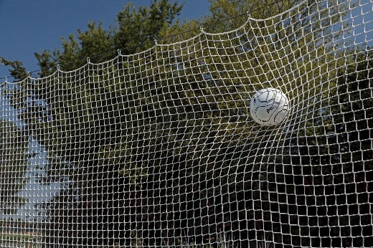
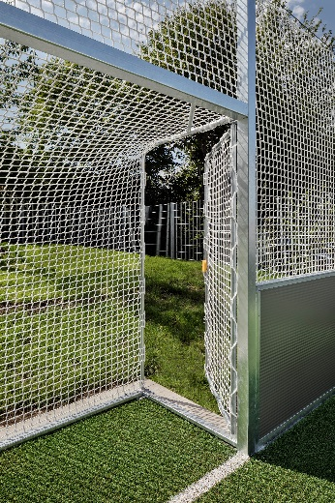
Polytan PolyPlay Arena_03+04.jpg
Barrier-free access to the playing field is located in the side of the goal. The netting is suspended and tied loosely at regular intervals to ensure that the ball cannot bounce back onto the field uncontrolled if it is struck hard.
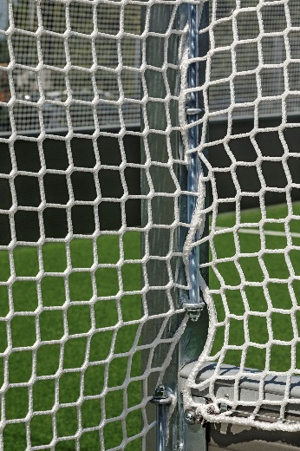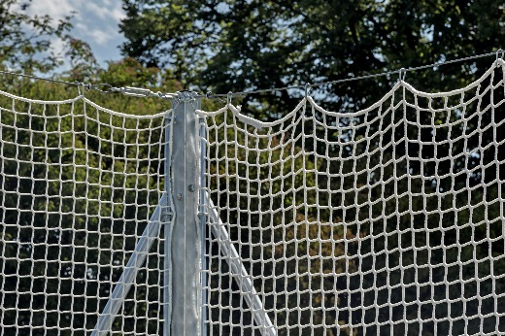
Polytan PolyPlay Arena_05+06.jpg
Galvanised steel forms the basis for the sturdy, rustproof frame construction of a Polytan Arena from Polytan.
Picture credits: Andreas Keller

Polytan GmbH:
To make the optimal surface for sporting success – that has been the ideal pursued by Polytan since 1969. With a constant eye on the latest findings in the field of sports medicine, the specialist in outdoor sports surfaces is continuously refining its synthetic surfaces and synthetic turf systems. Today's synthetic turf pitches not only feel like real grass, for example, they also have excellent playing qualities. High-quality synthetic surfaces now range from shock-absorbing soft-impact surfaces and multi-functional all-weather pitches all the way to high-speed surfaces for international athletics events. As well as developing, manufacturing and fitting its own sports surfaces, the spectrum of services provided by Polytan also includes line markings, repairs, cleaning and maintenance. All products meet current national and international standards and are duly certified by international sports federations such as FIFA, FIH, World Rugby and IAAF.

Agency contact:
Seifert PR GmbH (GPRA)
Barbara Mäurle
Zettachring 2a
70567 Stuttgart
0711 / 77918-26
barbara.maeurle@seifert-pr.de

Company contact:
Polytan GmbH
Tobias Müller
Gewerbering 3
86666 Burgheim
08432 / 8771
tobias.mueller@polytan.com

