Customised soft-impact surfaces from Polytan:
Long-lasting safety, easy maintenance and weather resistance
Thanks to their shock-absorbing effect, soft-impact surfaces help prevent severe (head) injuries. They are traditionally installed in educational institutions such as nurseries and schools as well as in children's play areas. Other locations include rehabilitation centres, leisure parks, retirement homes, outdoor gyms, swimming-pools and hotel facilities. Soft-impact products exist in the form of loose bulk material such as sand and gravel or as synthetic panels, seamless synthetic systems and synthetic turf. Polytan, the world's leading manufacturer of sports surfaces for outdoor use, offers high-grade soft-impact surfaces in two forms: as a seamless synthetic surface, Polytan FS, and with a synthetic turf finish in the Polytan FS Nature and Polytan FS Play versions.
While weather and rot-resistant synthetic soft-impact surfaces are a little more expensive to buy than traditional bulk material, the costs of acquisition pay off after only a few years. That's because – unlike sand, cork or bark mulch – the only cleaning that is required is for the surface, not deeper contamination, and there is no need to keep refilling areas that wear out quickly, such as the landing area of a slide. What is more, bulk materials can tend to lose some or even all of their shock-absorbing effect when wet.
That makes weather and rot-resistant synthetic surfaces much more hygienic, while the smooth surface also allows easy access for wheelchair users. (Point) loads caused by children on stilts, for instance, will not make any lasting impact either. To ensure a long life of more than ten years, Polytan recommends regular intensive wet cleaning every two to three years. Shaded areas will get dirtier much more quickly than areas that are exposed to sunlight and free of leaves. Optimum long-term maintenance is in any case guaranteed with the manufacturer's care plan.
Polytan FS soft-impact surface – for smooth, seamless shock absorption
To give planners and architects the greatest possible creative freedom, the water-permeable Polytan FS soft-impact surface is available in 24 standard colours and more than twice as many special colours. Colour adjustments are also possible, such as if a club or school crest is to be adapted. The surface can be installed not only on level but also on bumpy ground and slopes. The product generally consists of two layers: the top layer is 15 mm thick and manufactured from high-grade, completely newly produced EPDM granules (rubber). The necessary elasticity is provided by the second, absorbent layer made of recycled material. The thickness of the base layer varies between 30 and 115 mm, depending on the critical fall height of the play equipment. Soft-impact surfaces are appropriate up to a fall height of 3 m, above which the law requires railings.
The soft-impact surface is installed directly on site in a seamless in-situ process. The 2-8 mm rubber granules for the base layer and the 1-3.5 mm EPDM granules for the top layer are encased with a PU binder and bonded together. This in-situ installation allows the surface to adapt to all corners, edges and unevenness in the ground. The surface is sufficiently hard to be walked on after about 24 hours. Its water permeability depends on the chosen layer thicknesses, but is far above the requirements set out in DIN EN 14877 "Synthetic surfaces for outdoor sports areas".
Polytan FS conforms to fire safety class B_{fl} – s1 for flooring, so is classed as hardly flammable. The surface can easily withstand great heat up to and over 100 °C, while the impact noise properties and sound insulation can be regarded as generally positive.
Polytan FS Nature and FS Play – fall protection combined with synthetic turf
It was at the 2015 International Trade Fair for Amenity Areas, Sports and Pool Facilities (FSB) that Polytan first presented its new Polytan FS Nature and Polytan FS Play soft-impact surfaces. What is unusual about them is that they combine the attributes of two product worlds: shock-absorbing surfaces and textured (crimped) synthetic turfs.
The soft-impact surfaces consist of a thick, elastic base layer and a synthetic turf filled with quartz sand. As with the seamless Polytan FS soft-impact surface, the thickness of the elastic layer depends on the critical fall height of the play equipment.
The look of FS Nature comes very close to that of natural turf, as the filaments (stalks) are composed of light and dark green fibres. With green or blue synthetic turf surfaces and colour inlays in the form of graphics or hopscotch, Polytan FS Play offers additional scope for design freedom. The CoolPlus function, which reflects sunlight, helps to protect the surface of the turf from overheating in the summer.
Legal requirements on soft-impact surfaces
The requirements on soft-impact surfaces are essentially laid down in the European DIN EN 1176 "Playground equipment" and DIN EN 1177 "Impact attenuating playground surfacing" standards. These standards specify that impact attenuating surfaces must always be installed below play equipment from a free fall height of 60 cm and under equipment that causes a forced motion (e.g. see-saws and rocking items). How much safety a soft-impact product offers is indicated by its HIC value. HIC stands for Head Injury Criterion and is an indicator of the severity of head injuries. In the case of soft-impact materials in children's play areas, the maximum HIC reading of 1000 ensures that no head injuries with permanent consequences are caused through falls. It is to be regarded as equivalent to the critical fall height. The lower the HIC reading, the better the head of the falling child is protected. Every soft-impact surface must be tested by an independent test institution in compliance with DIN 1177. The manufacturer should also have an independent test institution verify whether certified product systems are used. This can be ensured through evidence of quality, such as the RAL 943/3 quality mark.
A further legal requirement to be considered when planning is the German "GUV-SR 2002 – Guidelines for kindergartens – Construction and equipment".

Captions:
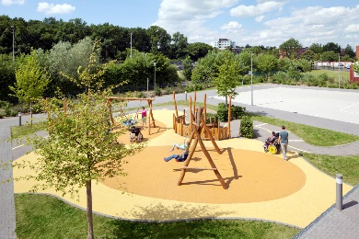 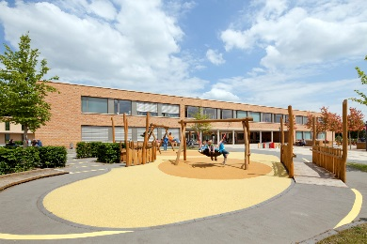
Polytan_Kästner Schule_01.jpg Polytan_Kästner Schule_02.jpg
(photographs: Claudia Dreyße)
The outside facilities of the Erich Kästner School won the special German Playground Award (SPIELRAUM-Preis) in 2015. Suitable for all year groups, the play and communication space was designed by landscape architects wbp. The yellow soft-impact surface was supplied by Polytan.
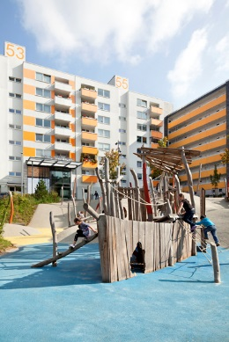 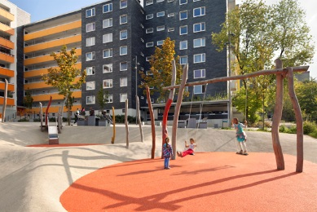
Polytan_Hustadt_01.jpg Polytan_Hustadt_02.jpg
(photographs: Claudia Dreyße)
The seamlessly installed Polytan SE synthetic surface allows entire adventure playgrounds to be created – as shown here in the urban redevelopment of the Innere Hustadt district in Bochum by landscape architects wbp.

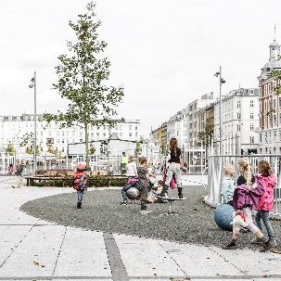
Israelplatz_Polytan_6.jpg (picture credit: Rasmus Hjortshøj – COAST)
The Polytan FS soft-impact surface was installed in understated grey when Israels Plads in Copenhagen was redeveloped.
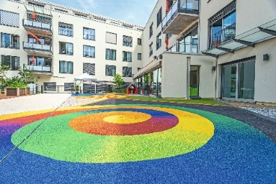
Paulinenhilfe_Polytan_2.jpg (picture credit: Polytan)
At the architect's request, the Polytan FS soft-impact surface in Stuttgart's Paulinenpark was finished in flowing colour gradients. The area is part of a barefoot path and also a hard-standing area for the fire service in the event of emergencies.
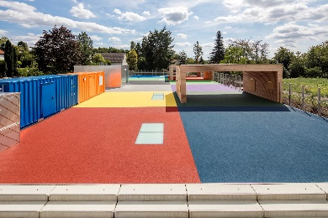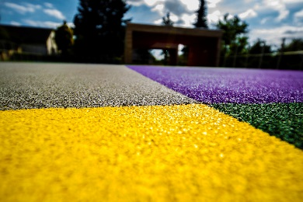
Polytan_Kita_Heimbach_Weis_2(5).jpg
(picture credit: Tomislav Vukosav for Polytan)
Coloured soft-impact surfaces from Polytan transform the some 840 m² roof of a childcare centre into an unusual adventure playground for children that also protects them from injury.

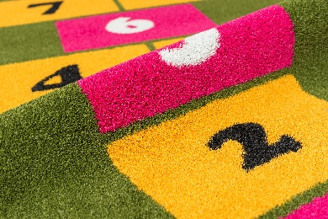 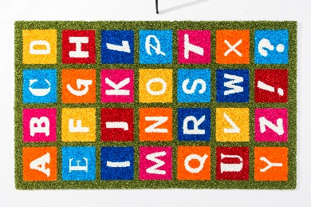
Polytan_FS_Play_01.jpg Polytan_FS_Play_02.jpg
(picture credit, both: Polytan)
With green or blue synthetic turf surfaces and colour inlays in the form of graphics or hopscotch, the new Polytan FS Play soft-impact surface offers additional scope for design freedom.
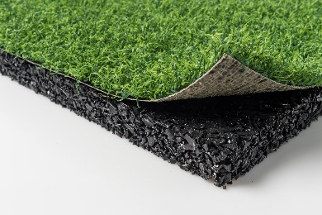
Polytan_FS_Nature_system.jpg (picture credit: Polytan)
The upper layer of the Polytan FS Nature soft-impact surface consists of a crimped synthetic turf that is pleasantly soft to the touch, while the BiColour design (light and dark green fibres) gives it the appearance of natural grass.

Polytan GmbH:
To make the optimal surface for sporting success – that has been the ideal pursued by Polytan since 1969. With a constant eye on the latest findings in the field of sports medicine, the specialist in outdoor sports surfaces is continuously refining its synthetic surfaces and synthetic turf systems. Today's synthetic turf pitches not only feel like real grass, for example, they also have excellent playing qualities. High-quality synthetic surfaces now range from shock-absorbing soft-impact surfaces and multi-functional all-weather pitches all the way to high-speed surfaces for international athletics events. As well as developing, manufacturing and fitting its own sports surfaces, the spectrum of services provided by Polytan also includes line markings, repairs, cleaning and maintenance. All products meet current national and international standards and are duly certified by international sports federations such as FIFA, FIH and IAAF.

Agency contact:
Seifert PR GmbH (GPRA)
Barbara Mäurle
Zettachring 2a
70567 Stuttgart
0711 / 77918-26
barbara.maeurle@seifert-pr.de

Company contact:
Polytan GmbH
Tobias Müller
Gewerbering 3
86666 Burgheim
08432 / 8771
tobias.mueller@polytan.com

