IAAF Diamond League in Africa for the first time:
Top marks for Polytan synthetic surface at inaugural meeting in Morocco
Now in its seventh year, the IAAF Diamond League has firmly established itself on the international elite sport calendar as a high-carat series of athletics events. Having been held in Asia, Europe, the Middle East and the USA, one of the 14 competition days of the season has now been staged in Africa for the first time, with some of the world's best athletes competing for the coveted podium finishes in Rabat on 22 May 2016. The "Meeting international Mohammed VI d'Athlétisme Rabat" thus replaces New York as a host venue.
The German sports surface specialist from Burgheim won the contract for installing a new synthetic surface in Morocco's second largest stadium, the Stade Moulay Abdallah, at the beginning of 2016. That makes it the fifth Diamond League stadium already to have a Polytan sports surface. The main challenge was that the IAAF Class 1 certified surface had to be laid and certified in a near-record time of just 4 weeks – despite sometimes difficult weather conditions.
The inaugural event in Africa, which was something of a milestone in the development of sport on the continent, proved to be a huge success for everyone involved: four world bests for the year, two national records and ten meeting records delighted athletes, spectators and the organisers alike. The performance of the Ethiopian Almaz Ayana in particular led to frenetic celebrations after she ran the fifth fastest 5,000 metres time in history on the track. She was less than six seconds behind the world record, just two behind her personal best time.
And the athletes themselves were full of praise. Long-jump winner Rushwal Samaai: "This is the best competition that I have ever been in. Everything was amazing, the new track is also very good. My technique worked well and my run up is getting better. The most important for me is to be consistent in all my competitions because the level in this event is extremely high".
All the athletics disciplines were held on the fast Polytan M synthetic surface, which in the Stade Moulay Abdallah was installed in the national colours of red and green. The competition surfaces are laid in classic tile red, all other side and ancillary areas in signal green, a strong shade that is similar in colour to the green star in the Moroccan flag.
www.polytan.com

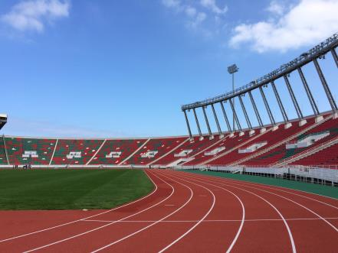
Polytan_Diamond_league_Rabat 1.JPG
A Polytan M synthetic surface was used for the new athletics track (type A competition track), which has 8 lanes.

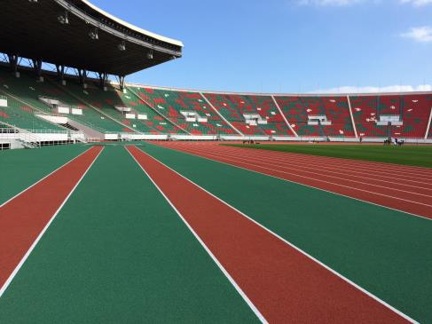
Polytan_Diamond_league_Rabat 2.JPG
While the track is laid in tile red, the outer areas were given a green synthetic surface.

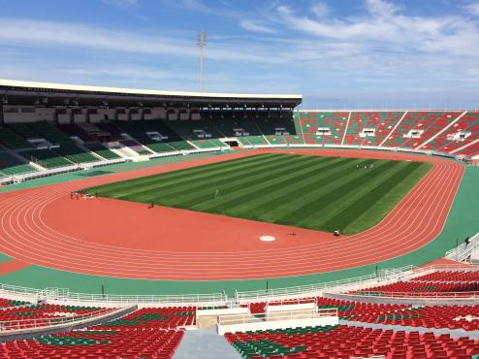
Polytan_Diamond_league_Rabat 3.JPG
The Stade Moulay Abdallah was opened in 1983 and has space for about 52,000 spectators.
Picture credits: Polytan GmbH

Polytan GmbH:
To make the optimal surface for sporting success – that has been the ideal pursued by Polytan since 1969. With a constant eye on the latest findings in the field of sports medicine, the specialist in outdoor sports surfaces is continuously refining its synthetic surfaces and synthetic turf systems. Today's synthetic turf pitches not only feel like real grass, for example, they also have excellent playing qualities. High-quality synthetic surfaces now range from shock-absorbing soft-impact surfaces and multi-functional all-weather pitches all the way to high-speed surfaces for international athletics events. As well as developing, manufacturing and fitting its own sports surfaces, the spectrum of services provided by Polytan also includes line markings, repairs, cleaning and maintenance. All products meet current national and international standards and are duly certified by international sports federations such as FIFA, FIH and IAAF.

Agency contact:
Seifert PR GmbH (GPRA)
Barbara Mäurle
Zettachring 2a
70567 Stuttgart
0711 / 77918-26
barbara.maeurle@seifert-pr.de

Company contact:
Polytan GmbH
Tobias Müller
Gewerbering 3
86666 Burgheim
08432 / 8771
tobias.mueller@polytan.com

