Polytan offers alternative to brick-red synthetic surface:
Polytan "Chili red" injects vibrancy into running tracks
Until a few decades ago, synthetic surfaces in athletics stadiums and training facilities were only installed in the classic "running track red". This shade is more accurately described as "rust" and is also familiar to us from traditional tiled roofs. Its origins can be traced back to the popular cinder tracks of the past, whose compacted top layer consisted of red sandstone as well as cinder and sand.
As one of the world's leading manufacturers of synthetic sports surfaces for outdoor use, Polytan has noticed that new and, above all, more striking colours have been enjoying increasing popularity for running tracks, all-weather pitches and soft-impact surfaces for some years. And this goes for local authorities, stadium operators, clubs and schools in equal measure. In 2014, for example, Stockholm Olympic Stadium was the recipient of a Polytan PUR running track with areas of blue in selected sections, whilst a bright "pea green" track is one of the architectural highlights of an award-winning Munich primary school. Red is now celebrating its comeback as a trendy new colour alongside a wide variety of green and blue shades – and specifically the new Polytan Chili red.
Compared with the classic brick red, this bold and brilliant shade of red scores significantly more highly in terms of colour intensity. Polytan surfaces poured in-situ and those consisting of highly compressed granules are available in Polytan Chili red, so this brilliant colour can inject "vibrancy" into running tracks, schoolyards, playgrounds and multipurpose areas alike. Like all Polytan colours, this special new shade is colour-fast and UV-stable and stays bold and brilliant for decades.

Captions:
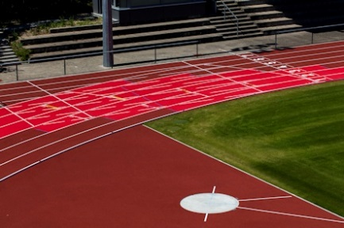
Polytan_Chili_red_2a.jpg Polytan_Chili_red_2b.jpg
(picture credit: Polytan/Tomislav Vukosav)
To make the exchange zones stand out visually for relay runners, these areas in the Waldstadion Walldorf were installed in bright Chili red. The rest of the track is the classic brick red.

Polytan_Chili_red_3.jpg (picture credit: Polytan/Tomislav Vukosav)
From soft-impact surfaces on children's play areas to athletics tracks for elite international athletes – Polytan has the right synthetic surface in its portfolio for every purpose. The water-permeable Polytan M surface was installed in the Waldstadion Walldorf.

Polytan GmbH:
To make the optimal surface for sporting success – that has been the ideal pursued by Polytan since 1969. With a constant eye on the latest findings in the field of sports medicine, the specialist in outdoor sports surfaces is continuously refining its synthetic surfaces and synthetic turf systems. Today's synthetic turf pitches not only feel like real grass, for example, they also have excellent playing qualities. High-quality synthetic surfaces now range from shock-absorbing soft-impact surfaces and multi-functional all-weather pitches all the way to high-speed surfaces for international athletics events. As well as developing, manufacturing and fitting its own sports surfaces, the spectrum of services provided by Polytan also includes line markings, repairs, cleaning and maintenance. All products meet current national and international standards and are duly certified by international sports federations such as FIFA, FIH and IAAF.

Agency press contact:
Seifert PR GmbH (GPRA)
Barbara Mäurle
Zettachring 2a
70567 Stuttgart
0711 / 77918-26
barbara.maeurle@seifert-pr.de

Company press contact:
Polytan GmbH
Tobias Müller
Gewerbering 3
86666 Burgheim
08432 / 8771
tobias.mueller@polytan.com

