Redevelopment of Norikus Bay in Nuremberg
Waterside activities
Nuremberg has gained another popular recreational area: Norikus Bay on the Wöhrder See lake. The revitalised waterfront park has a bathing cove as well as features including a fitness trail and a water playground. Both of these activity areas were covered with high-quality synthetic surfaces from Polytan, duly adapted to the specific requirements.
The Wöhrder See was created back in the 1970s when the Pegnitz river was dammed up in the Nuremberg district of Wöhrd, becoming a popular recreational area for the city's residents. The 70 ha site lost its attractiveness over the course of time, however, as the quality of the water worsened and the bay silted up – to the point that extensive regeneration was required. The contract was awarded to Hackl Hofmann Landschaftsarchitekten, a firm of landscape architects based in Eichstätt, within the scope of an invitation to tender under the German professional services contract regulations (VOF). They revitalised Norikus Bay and divided the recreational area into three zones: a nature reserve, the waterfront park and the bathing cove.
Bathing cove with beach and grassy area
The bathing cove is separated from the rest of the Wöhrder See by a man-made dam and, with a maximum depth of 1.34 m, is also suitable for non-swimmers. A second, reed-filled basin cleans the water from the bathing cove before it flows through the natural surroundings of the Goldbach tributary and back into the Pegnitz. An extensive embankment was built along the old shoreline, creating a large grassy area for sunbathing with a sandy beach and level access to the water. A new energy and environment station by the water will bring the latest news on the environment and countryside from autumn 2019.
Since Norikus Bay reopened in 2018, the water park and the fitness trail have proved to be magnets for visitors – and both zones are fitted out with synthetic surfaces from Polytan.
The water playground – endless enjoyment for children
A large sandpit shaped like a polygon is the central point of the new water playground. It is surrounded by a watercourse equipped with play elements. Children can have fun while following the water all the way from its source and into the lake. A water play area with sprinklers and groundwater fountains rounds off the fun for younger park visitors.
Water-impermeable Rekortan M tartan surface for the watercourse
The watercourse is marked out by a turquoise, water-impermeable surface made from synthetic materials. This Rekortan M tartan surface is seamlessly installed by Polytan using the in-situ construction method. Its outstanding cushioning and tread elasticity mean that it is normally at home in the world's leading athletics stadiums. Numerous world records and personal bests have already been achieved on it. Not only does its turquoise hue light up the course of the stream, it also offers children a soft base on which to play.
The landscape architects opted for water-impermeable natural stone paving in the stepped area of the watercourse by way of a contrast.
PolyPlay S tartan provides a safe non-slip surface by the sprinklers
Wherever there was a need for a non-slip, seamless tartan surface in the water playground, for example by the sprinklers and groundwater fountains, the material chosen by the designers was a turquoise PolyPlay S from Polytan. This durable all-rounder is water-permeable, allowing the cushioned surface to dry off quickly. This synthetic surface is generally used for schools and multipurpose facilities as well as jogging trails, senior citizen complexes and rehabilitation facilities as it has a smooth surface with good ball bounce behaviour but is nevertheless non-slip.
While the water playground enjoys great popularity among youngsters, the fitness trail is designed primarily for young people and adults. The blue trail with a tartan surface zigzags through the park and measures just over ten metres at its widest point. It is just over two metres at its narrowest point.

The fitness trail – sport in the park with callisthenics
Callisthenics is a modern version of the "trim trail" in which a series of strength training stations with bodyweight exercises are set out at short intervals. The sports surfaces chosen by the designers of landscape architects Hackl Hofmann were the water-permeable, optimally cushioned PolyPlay S and PolyPlay FS synthetic surfaces from Polytan in a bright sky blue shade.
The smooth yet non-slip surface of the PolyPlay S tartan system impressed the designers just as much as it did in the watercourse and water playground zones. The PolyPlay FS soft-impact surface was used wherever there was a need for fall protection, i.e. under any callisthenics equipment with a drop height of ≥60 cm. This consists of an approx. 15 mm thick top layer made of sky blue EPDM granules and a 100 mm thick elastic layer made of recycled rubber materials.
DIN EN 1177-compliant safety testing
All synthetic surfaces from Polytan are proven to be weather- and rot-resistant, thus guaranteeing a long lifespan and low maintenance costs. They comply with DIN EN 1177 and are safety-tested to RAL or DIN-Certco requirements. Children in the water playground and athletes on the fitness trail are thus offered optimal protection from injury – thanks to the optimal cushioning of the seamlessly installed base.
CONSTRUCTION SITE SIGN:
Project: Wöhrder See/Norikus Bay
Awarding authority: City of Nuremberg
Planning: Hackl Hofmann Landschaftsarchitekten, Eichstätt
Construction period: 2015 to 2018
Execution of soft-impact surface: Gustav Biedenbacher, Garten- und Landschaftsbau, Kammerstein
Water playground, watercourse area: Synthetic surface Rekortan M, water-impermeable, approx. 306 m², turquoise
Water playground, sprinklers and groundwater fountains area: Synthetic surface PolyPlay S, approx. 575 m², turquoise
Fitness trail: synthetic surface: PolyPlay S, approx. 460 m², sky blue
Fitness trail, equipment area: PolyPlay FS, approx. 231 m², sky blue
Captions:
Photos (all): Hackl Hofmann Landschaftsarchitekten
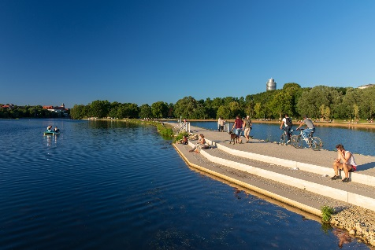
Park-Wöhrder See-Norikusbucht-Nürnberg-Hackl-Hofmann-Landschaftsarchitekten-03.jpg
The elevated dam is 1.00 m high, 2.5 m wide and 400 m long. It offers walkers and cyclists a unique view across Norikus Bay.

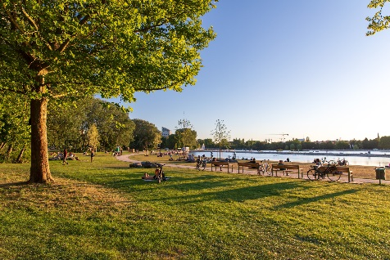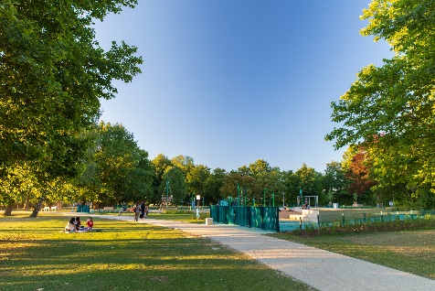
Park-Wöhrder See-Norikusbucht-Nürnberg-Hackl-Hofmann-Landschaftsarchitekten-01+02.jpg
With lots of trees and a large expanse of grassland, the redesigned green space is an inviting place to relax and enjoy nature.

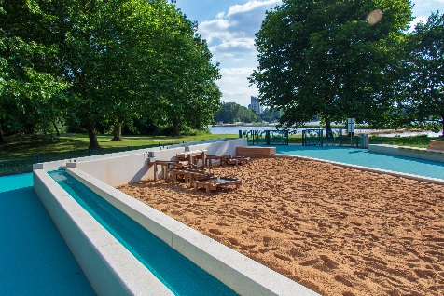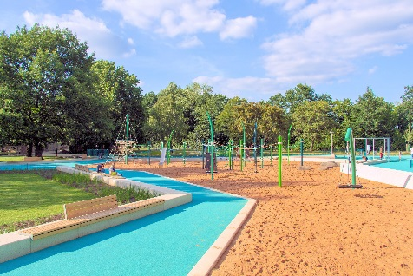
Wasserspielplatz-Wöhrder See-Norikusbucht-Nürnberg-Hackl-Hofmann-Landschaftsarchitekten-02+03.jpg
The watercourse in the water playground is fitted out with a water-impermeable Rekortan M tartan surface from Polytan. The turquoise colour highlights the "water" theme.

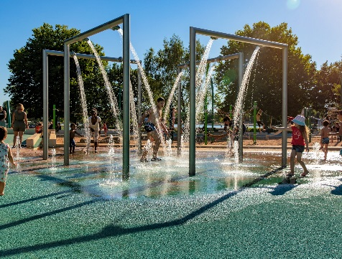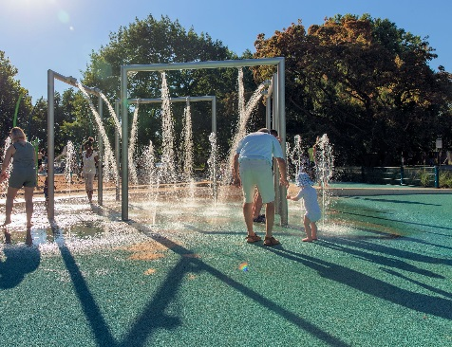
Wasserspielplatz-Wöhrder See-Norikusbucht-Nürnberg-Hackl-Hofmann-Landschaftsarchitekten-04 + 05.jpg
A smooth, non-slip PolyPlay S synthetic surface in turquoise was installed in the area around the showers and groundwater fountains. It is water-permeable so that the surface can dry off quickly.

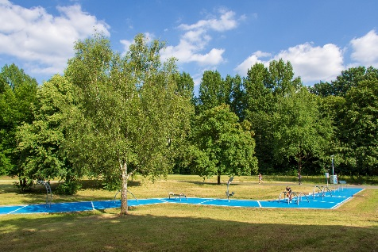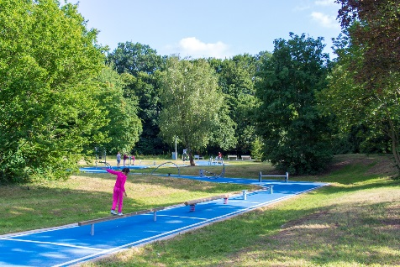
Bewegungspark-Wöhrder See-Norikusbucht-Nürnberg-Hackl-Hofmann-Landschaftsarchitekten-01 + 02.jpg
The fitness trail winds through the landscaped park like a luminous blue strip. The water-permeable PolyPlay FS fall protection surface was chosen to provide cushioning under the callisthenics workout equipment.

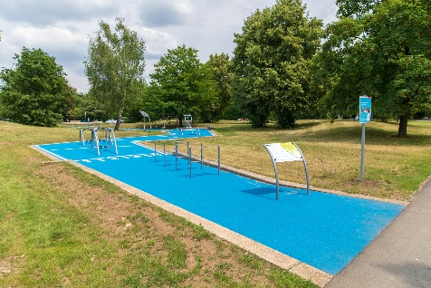 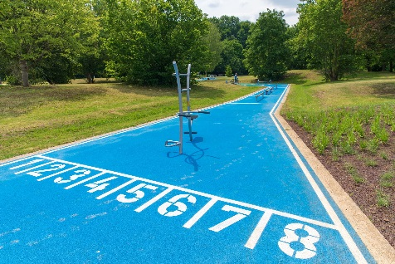
Bewegungspark-Wöhrder See-Norikusbucht-Nürnberg-Hackl-Hofmann-Landschaftsarchitekten-05 + 06.jpg
Apart from fall protection under the equipment, the water-permeable PolyPlay S tartan surface from Polytan provides optimal cushioning for fitness enthusiasts in the park.

Polytan GmbH:
To make the optimal surface for sporting success – that has been the ideal pursued by Polytan since 1969. With a constant eye on the latest findings in the field of sports medicine, the specialist in outdoor sports surfaces is continuously refining its synthetic surfaces and synthetic turf systems. Today's synthetic turf pitches not only feel like real grass, for example, but they also have excellent playing qualities. High-quality synthetic surfaces now range from shock-absorbing soft-impact surfaces and multi-functional all-weather pitches all the way to high-speed surfaces for international athletics events. As well as developing, manufacturing and fitting its own sports surfaces, the spectrum of services provided by Polytan also includes line markings, repairs, cleaning and maintenance. All products meet current national and international standards and are duly certified by international sports federations such as FIFA, FIH, World Rugby and IAAF.

Agency contact:
Seifert PR GmbH (GPRA)
Barbara Mäurle
Zettachring 2a
70567 Stuttgart
0711 / 77918-26
barbara.maeurle@seifert-pr.de

Company contact:
Polytan GmbH
Tobias Müller
Gewerbering 3
86666 Burgheim
08432 / 8771
tobias.mueller@polytan.com

