Polytan presented the unfilled LigaTurf Motion synthetic turf at FSB 2019:
Three yarns, no infill
A highly functional synthetic turf system for football that doesn't use infill crumb? Thanks to Polytan, what was previously only standard in field hockey is now also finding its way into the world of amateur and professional football. LigaTurf Motion, the product innovation presented at this year's FSB, combines three different synthetic yarns in one system for the first time, offering playing properties that come very close to the sand and rubber-filled synthetic turf systems that have been proving their worth for many years.
Polytan has responded to the public debate about infill in Germany over recent months by developing a synthetic turf for football that doesn't use a rubber crumb, cork or any other performance infill whatsoever. What is so special about the innovation is that it doesn't come at the expense of the playing properties of the pitch – they remain roughly as good as those of the sand and rubber-filled synthetic turf systems that have been established for many years, where it is the infill that is primarily responsible for the good playing properties and player protection.
With its LigaTurf Motion, Polytan has now succeeded in bringing onto the market a synthetic turf that is also suitable for football despite the lack of infill. It was the clever combination of three different synthetic yarns in one product that made this development possible.
Three filaments, one synthetic turf system
The first LigaTurf RS+ filament used in the LigaTurf Motion is smooth and was originally developed for synthetic turf systems that are employed in professional football especially. Since the LigaTurf RS+ filaments are longer than the rest of the surface of the turf, they stand out visually and also ensure a pleasantly soft feel on the skin when tackling. Other positive properties of the fibre include a very good rebound capacity and high resistance to wear.
The second filament, the LigaGrass Pro yarn, has a crimped structure, helps to stabilise the turf and generates the necessary traction for the footballers. Fullness and an appearance similar to natural turf are provided by the third filament in the group, the likewise crimped and particularly soft Synergy yarn. All three filament types are hard-wearing and UV-stable, while the patented CoolPlus pigments reduce the amount by which the surface of the turf heats up on hot days.
The TriColour scheme combining three shades of green in one yarn gives the pitch a fresh and natural look. Friedemann Söll, Chief Product Officer Region EMEA of Polytan, sees enormous potential in the product development presented for the first time at FSB: "The LigaTurf Motion CoolPlus allows us to offer all football clubs an easy-to-maintain synthetic turf system with very good playing properties that doesn't use any infill whatsoever."

Captions:
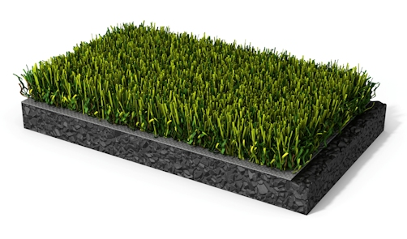
Polytan-Kunstrasen-LigaTurf-Motion.jpg
Polytan presented its new LigaTurf Motion synthetic turf system at FSB 2019. This football turf dispenses entirely with rubber crumb, cork or other performance infill, but still offers very good playing properties.

Polytan GmbH:
To make the optimal surface for sporting success – that has been the ideal pursued by Polytan since 1969. With a constant eye on the latest findings in the field of sports medicine, the specialist in outdoor sports surfaces is continuously refining its synthetic surfaces and synthetic turf systems. Today's synthetic turf pitches not only feel like real grass, for example, they also have excellent playing qualities. High-quality synthetic surfaces now range from shock-absorbing soft-impact surfaces and multi-functional all-weather pitches all the way to high-speed surfaces for international athletics events. As well as developing, manufacturing and fitting its own sports surfaces, the spectrum of services provided by Polytan also includes line markings, repairs, cleaning and maintenance. All products meet current national and international standards and are duly certified by international sports federations such as FIFA, FIH, World Rugby and IAAF.

Agency contact:
Seifert PR GmbH (GPRA)
Barbara Mäurle
Zettachring 2a
70567 Stuttgart
0711 / 77918-26
barbara.maeurle@seifert-pr.de

Company contact:
Polytan GmbH
Tobias Müller
Gewerbering 3
86666 Burgheim
08432 / 8771
tobias.mueller@polytan.com

