Retopping and modern SmarTracks technology:
High-quality track refurbishment at Juliska Stadium in Prague
The client who contracted Polytan to refurbish the track at the Juliska football and athletics stadium in Prague showed no fear of bright colours: having now been retopped, both sections boast gleaming "rosé" surfaces, while the outer circumference is a bright "Capri blue". The actual running track was resurfaced in a classic brick red colour. The Burgheim-based sports surface specialist did not just renovate all the synthetic surfaces, however. It also installed Polytan SmarTracks technology at the sports facility, an invisible time and data recording system that can be used to make a comprehensive diagnosis of an athlete's performance.
The Juliska Stadium was opened in Prague, the capital city of the Czech Republic, in 1960. Having undergone extensive alterations in 1975, the stadium now holds around 18,800 spectators with seating for 8,150, some sections of which are covered. The sports facility has a 105 x 68 metre real grass playing field surrounded by a tartan track, which makes it suitable for football as well as track and field athletics. The stadium is owned by the Ministry of Defence of the Czech Republic. Juliska Stadium used to be the home ground of the FK Dukla Prag football club, an army team which celebrated its greatest sporting successes in the 1950s and 1960s. The club of the same name was promoted back to the top flight of Czech football in the 2010/11 season, thus enabling it to relive past glories. And the track and field athletes of ASC Dukla Prag can look back on the club's illustrious history, with Olympic medallists and world champions such as Jan Železny, Roman Šebrle, Tomáš Dvořák, Barbora Špotáková among others.
As well as matches in the top division of Czech football, the annual Memoriál Josefa Odložila athletics meeting is also held here.

Track retopping with IAAF certification
The ageing running track was fully refurbished by Polytan between July and September 2018. The original synthetic surface, Polytan PUR, was nearly 20 years old. Rekortan PUR, a water-impermeable, multi-layer poured in-situ system also made by Polytan, was chosen as the new retopping system. This high-speed sports surface offers very fast acceleration combined with optimum shock absorption properties, making it the ideal base for personal bests, new records and international elite sport. The tartan track was certified for this purpose by the IAAF after being refurbished. The Capri blue outside section does not need to meet the requirements of runners, so it was fitted with the hard-wearing PolyPlay SE all-round surface from Polytan. This has a smooth surface with good ball bounce behaviour and is generally used for multipurpose facilities such as in schools.
Not only does the refurbished tartan track in Juliska Stadium have a surface which is ideally suited to running shoes with spikes thanks to its new interspersed granules, it has also been laid in some gleaming new colours. As well as the conventional brick red circular track, the two D-shaped inside sections were installed in a glowing rosé colour and the outer circumference in a bright Capri blue at the client’s request. Rosé and Capri blue are among the 24 standard colours of Polytan. Innovative synthetic materials and sealing systems are used to make them insensitive to factors such as heat, UV rays, frost and rain or mechanical influences during operation.
Czech Republic's first track with modern SmarTracks technology
Juliska Stadium was the first stadium in the Czech Republic to have Polytan SmarTracks installed. This is a data logging system which takes accurate measurements and facilitates daily training diagnostics without costly technical structures. As well as performance diagnostics, SmarTracks includes a precise time-measurement system. It keeps a record of running time, speed, step length, step frequency and jump height. The analysis tool is thus suitable for disciplines such as short-, middle- and long-distance running, hurdles and relays. Another special feature is that this technology can be used to record the movement data of several athletes simultaneously and then compare them.

The Polytan SmarTracks system is based on the interplay of three components: (1) SmarTracks magnetic timing gates embedded in the track out of sight. (2) A waistbelt with a sensor weighing just 12 g; it is worn by the athlete but does not restrict freedom of movement. It can simply be worn as a belt or clipped on. (3) The tried-and-tested SmarTracks diagnostics software by Polytan partner Humotion. This company specialises in capturing and analysing human motion data.
Incidentally, it wasn't just the running track that benefited from the sophisticated technology in Prague – so did the pole vault area, which now offers optimal training conditions as a result.
CONSTRUCTION SITE SIGN:
Owner: Ministry of Defence of the Czech Republic
Construction project: Juliska Stadium (Stadion na Julisce), Prague
Running track: 5,075 m² Rekortan PUR-RT, colour = brick red, d = 3 – 4 mm
Sections: 1,911 m² Rekortan PUR-RT, colour = rosé, d = 3 - 4 mm
Outer surfaces: 709 m² PolyPlay SE, colour = Capri blue, d = 40 mm / 10 mm
Installation period: July-September 2018

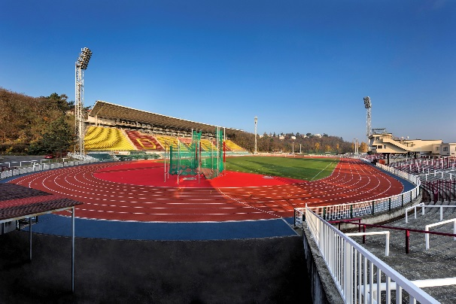
Polytan_Stadion_Juliska_01.jpg
In 2018 the entire track at the Juliska Stadion in Prague was retopped by Polytan and the invisible SmarTracks technology was installed.
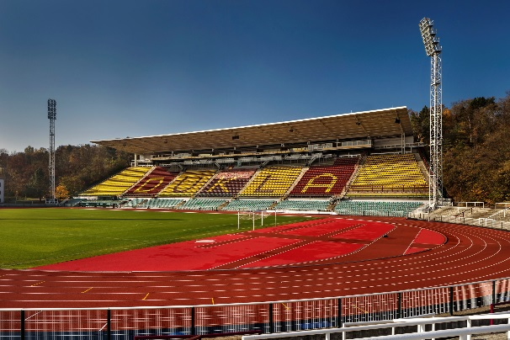
Polytan_Stadion_Juliska_02.jpg
The new track was fitted with the high-speed Rekortan PUR-RT surface by Polytan during a retopping project – making it ideally equipped for international track and field events.
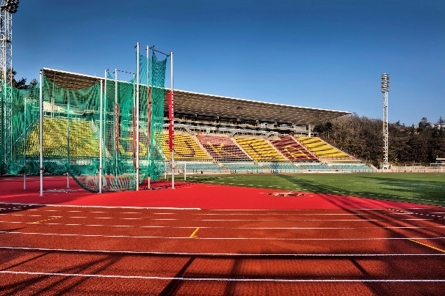
Polytan_Stadion_Juliska_03.jpg
The new synthetic surface Rekortan PUR-RT was installed in the sections in the colour "rosé" – the tartan track itself is a classic brick red.
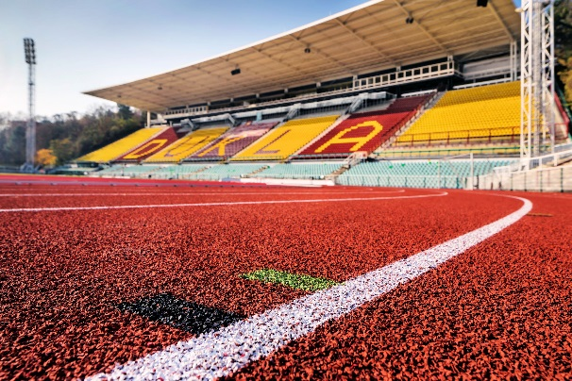
Polytan_Stadion_Juliska_04.jpg
The system is ideally suited to running shoes with spikes as the interspersed granules are visible on the synthetic surface.
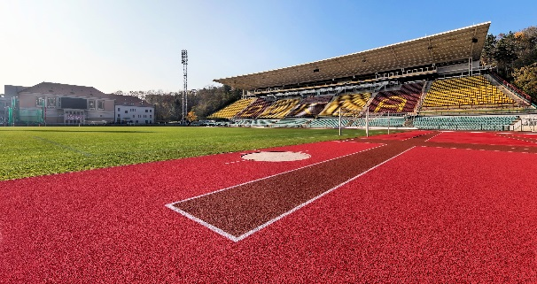
Polytan_Stadion_Juliska_05.jpg
The Juliska Stadium is the first in the Czech Republic to have been fitted with Polytan SmarTracks – not only on the track, but also in the pole vault area.
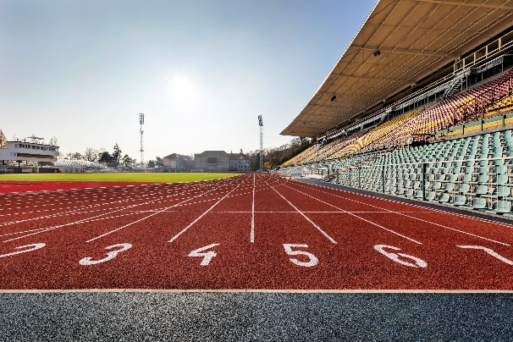
Polytan_Stadion_Juliska_06.jpg
The line markings are IAAF-certified so that international track and field events can also be held on the refurbished track in Juliska Stadium.
Picture credits (all): Andreas Keller / Polytan

Polytan GmbH:
To make the optimal surface for sporting success – that has been the ideal pursued by Polytan since 1969. With a constant eye on the latest findings in the field of sports medicine, the specialist in outdoor sports surfaces is continuously refining its synthetic surfaces and synthetic turf systems. Today's synthetic turf pitches not only feel like real grass, for example, but they also have excellent playing qualities. High-quality synthetic surfaces now range from shock-absorbing soft-impact surfaces and multi-functional all-weather pitches all the way to high-speed surfaces for international athletics events. As well as developing, manufacturing and fitting its own sports surfaces, the spectrum of services provided by Polytan also includes line markings, repairs, cleaning and maintenance. All products meet current national and international standards and are duly certified by international sports federations such as FIFA, FIH, World Rugby and IAAF.

Agency contact:
Seifert PR GmbH (GPRA)
Barbara Mäurle
Zettachring 2a
70567 Stuttgart
0711 / 77918-26
barbara.maeurle@seifert-pr.de
Company contact:
Polytan GmbH
Tobias Müller
Gewerbering 3
86666 Burgheim
08432 / 8771
tobias.mueller@polytan.com

