SportGroup Holding and Polytan invest in the Burgheim site:
Ground-breaking ceremony for a new office building
Burgheim, 9 September – With the ground-breaking ceremony for a new office building, SportGroup Holding has shown, together with its subsidiary Poytan, that the group of companies will remain loyal to its Burgheim-based headquarters in the future.
An elegant and energy-efficient building with space for 50 employees is taking shape on the company's own site, with completion scheduled for April next year. A total of 80 people are employed at the site. The volume of investment for the sustainable timber-frame construction made from industrially prefabricated system elements amounts to nearly two million euros. The manufacturing contract was awarded to Regnauer Fertigbau, a timber construction company from Seebruck am Chiemsee that has already won a variety of awards for innovation. The conceptual design comes from the Munich-based architecture firm jürgensarchitekten, with Natalie Jürgens as project leader. The building will boast an office environment designed for ease of communication, a showroom for products and applications, and a break room with direct access to the garden. Provision has been made to extend the presentation area by having a brick red track by the main entrance and a mini-pitch on the company premises. Landscape architects liebald + aufermann of Munich have been commissioned with the open-space design. The new and existing buildings will all be supplied from renewable energy sources. The new geothermal plant saves on resources by using geothermal energy for heating and groundwater for cooling.
Polytan and SportGroup Holding have had their headquarters in the region since 1969. The companies first traded under the name Firl + Schretter Sportstättenbau in Neuburg a. d. Donau. Their synthetic turf systems, synthetic tracks and soft-impact surfaces can be found all over the world today. The venues include famous competition arenas and football stadiums such as the Olympic Stadium in Amsterdam, the Stade de Suisse in Bern and the Universiade Sports Center Shenzhen in China.
SportGroup Holding employs around 1,000 people worldwide in over 20 companies. SportGroup is the world's leading company for synthetic outdoor sport surfaces, not least as a result of its acquisition of the reputable American AstroTurf brand in August 2016.
www.polytan.de
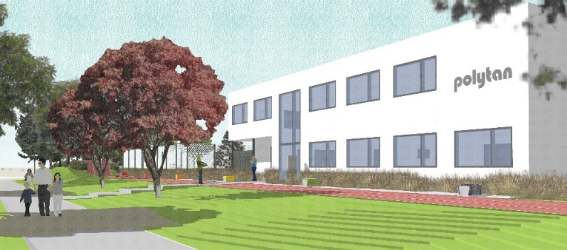
Polytan_Neubau_Burgheim.jpg (picture: jürgensarchitekten)
Polytan and SportGroup Holding is investing nearly 2 million euros in its Burgheim site with sustainable buildings constructed from prefabricated timber elements and renewable energy sources for heating and cooling.
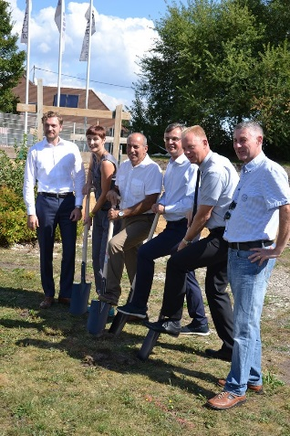
Polytan_Spatenstich_Burgheim.jpg (picture: Polytan GmbH)
9 September saw the official ground-breaking ceremony for the new office building in Burgheim. From left to right: Polytan managing director Mathias Schwägerl, architect Natalie Jürgens, site manager Harald Albertus, Polytan managing director Markus Deimling, mayor Michael Böhm and deputy mayor Andreas Flath.
Polytan GmbH:
To make the optimal surface for sporting success – that has been the ideal pursued by Polytan since 1969. With a constant eye on the latest findings in the field of sports medicine, the specialist in outdoor sports surfaces is continuously refining its synthetic surfaces and synthetic turf systems. Today's synthetic turf pitches not only feel like real grass, for example, they also have excellent playing qualities. High-quality synthetic surfaces now range from shock-absorbing soft-impact surfaces and multi-functional all-weather pitches all the way to high-speed surfaces for international athletics events. As well as developing, manufacturing and fitting its own sports surfaces, the spectrum of services provided by Polytan also includes line markings, repairs, cleaning and maintenance. All products meet current national and international standards and are duly certified by international sports federations such as FIFA, FIH and IAAF.

Agency contact:
Seifert PR GmbH (GPRA)
Barbara Mäurle
Zettachring 2a
70567 Stuttgart
0711 / 77918-26
barbara.maeurle@seifert-pr.de

Company contact:
Polytan GmbH
Tobias Müller
Gewerbering 3
86666 Burgheim
08432 / 8771
tobias.mueller@polytan.com

