Mini-pitches excite children and adults alike:
Great football fun in a small space
The summer fairy tale that put Germany in a collective football frenzy in 2006 lasted four weeks. Following this great sports festival, exactly 1,019 mini pitches were built from the financial surpluses. The German Football Association (DFB) initiated this one-off campaign with the aim of promoting young football players over the long term. To date, the 20 x 13 m mini pitches with synthetic turf, two goals, circumferential border and high rear goal nets are still very popular. Polytan implemented the project in 2008 as a DFB project partner. The sports floor manufacturer from Burgheim is still producing and installing the original DFB mini pitches with great success to this day.
Mini pitches are the perfect link between recreational fun and football, as they can be used at any age whenever the urge strikes. Especially in clubs, the mini football pitches now not only contribute to the general joy of the game, they can also actively promote the football skills of players of all ages. The court is increasingly used as an extended training area for coordination, sprint and technical training. which, for example, includes ball control in tight spaces, fair tackling and dribbling in 1:1 situations. If the pitch is completely closed with the help of side and roof nets, the ball remains in play at all times and supports players' technique, movement and responsiveness.
Depending on requirements, Polytan offers both stationary and mobile pitches in the standard dimensions 15 x 10 m, 20 x 13 m (German Football Association dimensions), 30 x 15 m, 40 x 20 m, as well as in any individual desired size. The synthetic turf pitches comply with the sports ground construction standard DIN 18035. The board systems produced by leading manufacturers are designed as freely accessible multisport facilities in accordance with DIN 15312. In the permanently installed variant, the surrounding perimeter system is fixed in the substructure using point foundations. An elastic layer under the synthetic turf ensures the necessary shock absorption. Compared to hard tennis courts, unkempt grass pitches or playing street soccer on asphalt, Polytan sports surfaces are much easier on the joints, offer greater running comfort and protect against major fall injuries.
The textured, low-maintenance synthetic turf (LigaGrass Synergy) is used as a playing surface, which on the one hand boasts high resistance and on the other hand is ideal for young players thanks to its soft filaments. The LigaGrass Synergy is only weighed down with quartz sand and is therefore used without infill granules (microplastics). Mini-pitches can also be equipped with water-permeable PolyPlay S and PolyPlay SE synthetic surfaces – ideal for basketball, volleyball and many other multisports.
A mini pitch can be a real eye-catcher with the integration of a club, city or school emblem. The sports surface does not automatically have to be the traditional green. We offer a wide variety of different colour tones and mixtures. The perimeter areas also offer space for advertising and thus the opportunity for additional revenue.
For more information on Polytan mini pitches, please visit: https://www.polytan.com/extras/mini-pitches-and-soccer-courts/
Captions:
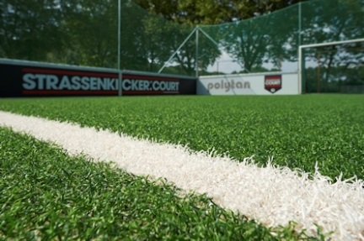 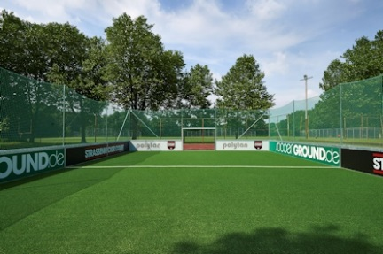
Polytan_Podolski_Stiftung_1_2.jpg
(Photo credits: Polytan/Sandra Schuck)
The integration of socially disadvantaged children and adolescents can be promoted with mini pitches – as the project "Strassenkicker.Court" by the Lukas Podolski Foundation in Cologne shows.
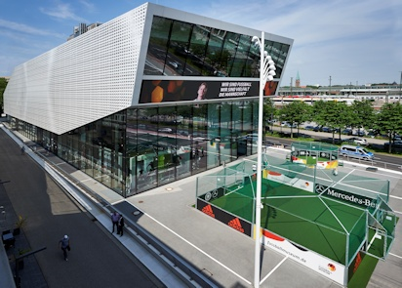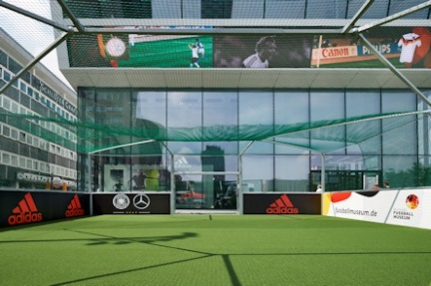
Polytan_Fußballmuseum_1_2.jpg
(Photo credits: Polytan/Sandra Schuck)
A mini pitch on the forecourt of the German Football Museum in Dortmund, which opened in 2015: Football history that children and young people can touch and participate in. In 2008/2009 alone, Polytan built over 1,000 of these throughout Germany.

Polytan GmbH:
Providing the perfect surface for athletic achievements – Polytan has pursued this claim since 1969. Always keeping an eye on the latest advances in sports medicine, this outdoor sports flooring specialist is continuously developing its synthetic sports surfaces and synthetic turf systems. For example, today's synthetic turf playing fields have a natural grass feel and excellent playing characteristics. High-quality synthetic surfaces are available, ranging from shock-absorbent, soft-impact surfaces to multifunctional all-weather courts and high-speed surfaces for international athletics events. In addition to its own development, production and installation of sports flooring, Polytan's range of services also includes lining, repair, cleaning and maintenance. All products comply with current national and international standards and hold all relevant certificates of international sports federations such as FIFA, FIH and IAAF.

Agency contact:
Seifert PR GmbH (GPRA)
Dr. Clemens Ottmers
Zettachring 2a
70567 Stuttgart, Germany
0711 / 77918-17
clemens.ottmers@seifert-pr.de

Company contact:
Polytan GmbH
Tobias Müller
Gewerbering 3
86666 Burgheim, Germany
08432 / 8771
tobias.mueller@polytan.com

